Clean Architecture

Zawartość

Architecture Principles 3

Principles 3

Dependency Inversion and Loose Coupling 3

Separation of concerns 4

Persistence ignorance 5

Architecture Types 5

Clean Architecture 6

Application Core 9

Setting up application core 9

Create an application 10

Mediator pattern 12

Implementation of MediatR and automapper 13

CQRS 17

CQRS in practice 19

Command 21

Validation 24

Add validation 26

Infrastructure 31

Description 31

Data Persistence 31

Persistence in practice 32

Repositories implementation 34

Add SendGrid 36

API 40

Introduction 40

Create Project 40

Controller 42

Return File 45

Add Swagger 48

Swagger in Practice 49

Tests 52

# Architecture Principles

## Principles

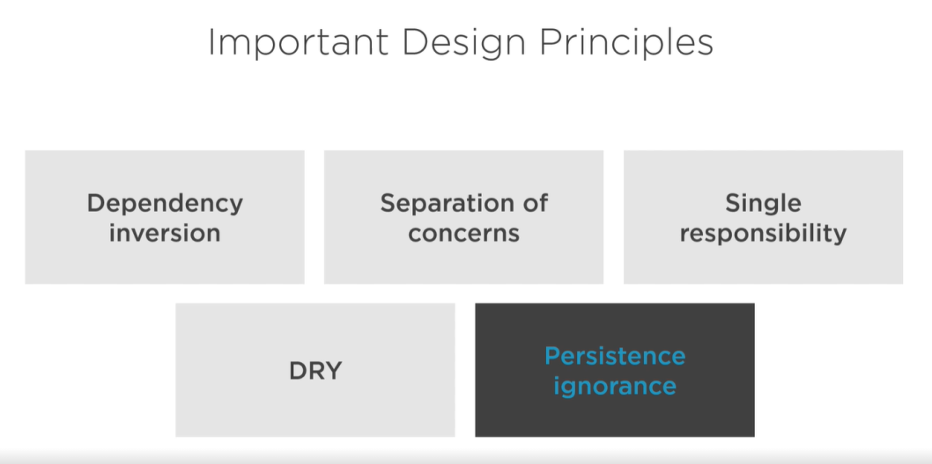

## Dependency Inversion and Loose Coupling

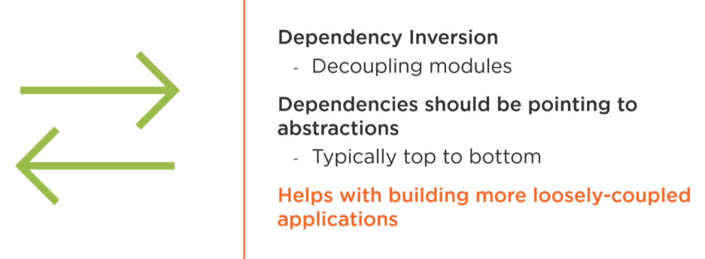

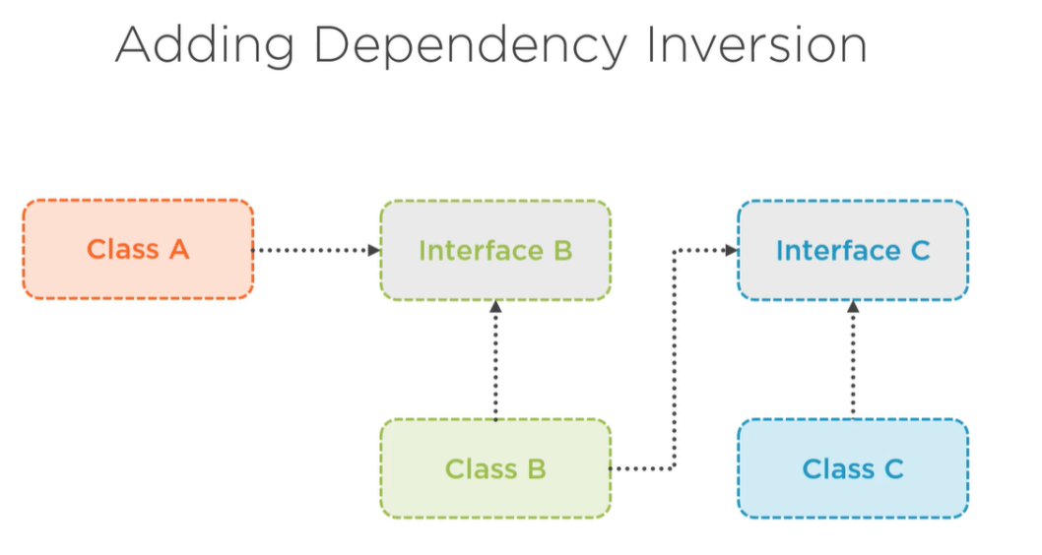

Dependency inversion is fifth rule of solid. This rules encourage dev to don’t create a particular object in class when is using. This pattern in named loose coupling. To fulfill all agreements inject a required class via constructor. In the most cases injection is created by interface and Dependency Injection. This code is easy to test because in integration test we can mock interface class and simulated its operation without particular implementation.

## Separation of concerns

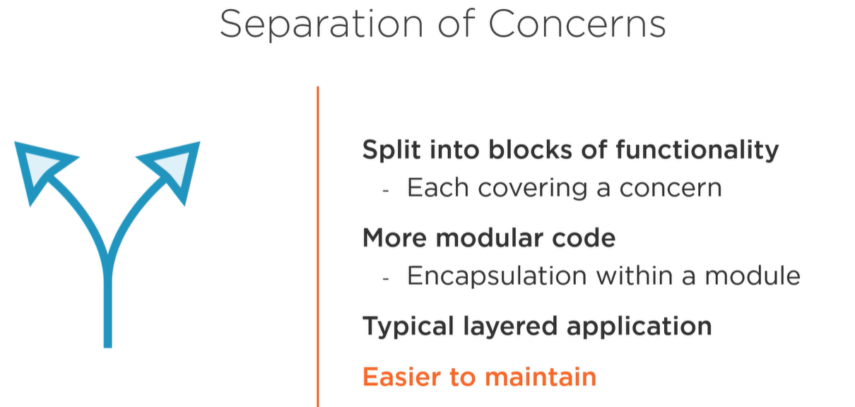

Each layer (library, part of application etc.) is separated from rest.

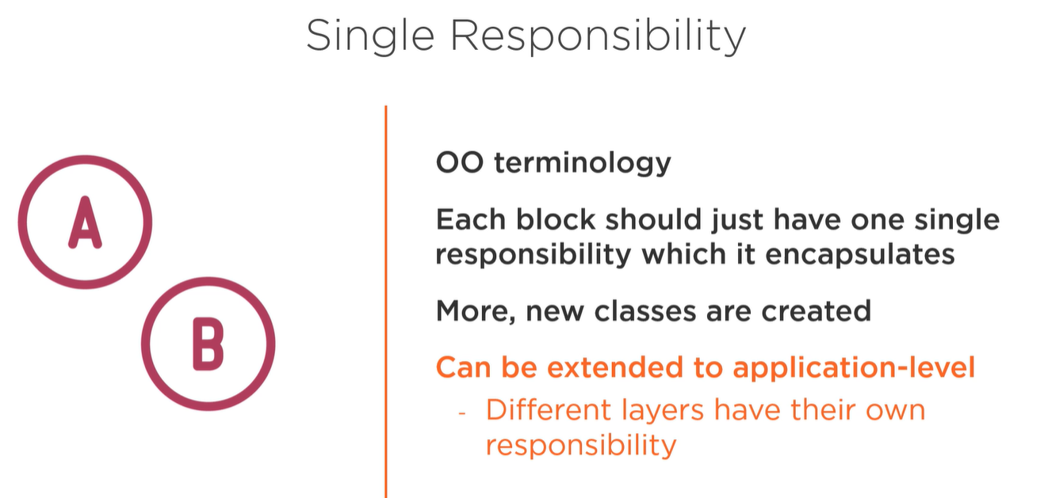

This is a single responsibility rules but in higher level (application not classes).

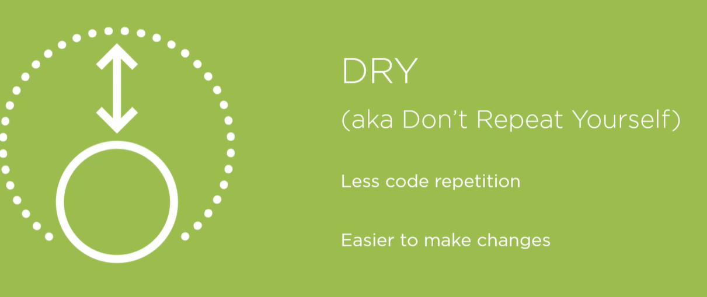

## Persistence ignorance

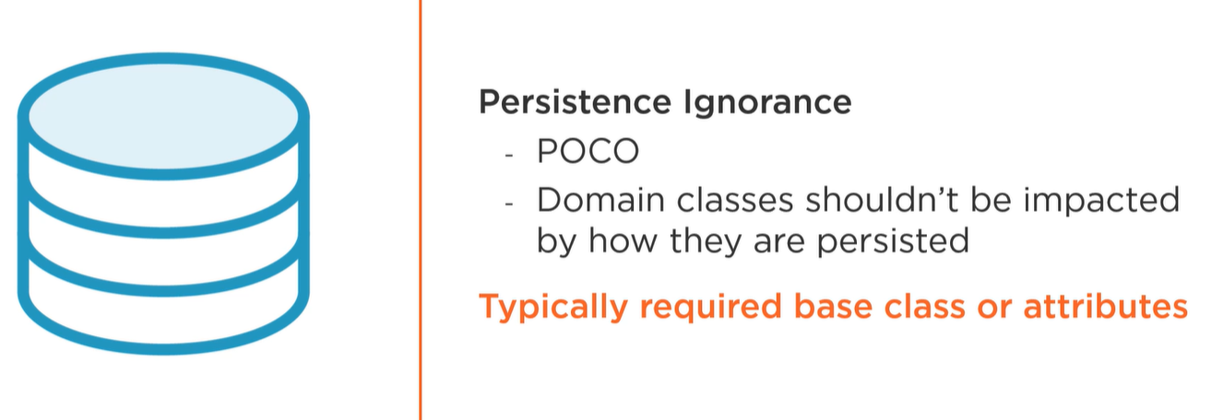

Domain object don’t make any information about dataAccess layer and don’t know anything about how they are persisted in db. Second thing to consider is divide from Entity model which will be persisted in Db and DTO (data transfer object) which will be send to view or send via endpoint.

## Architecture Types

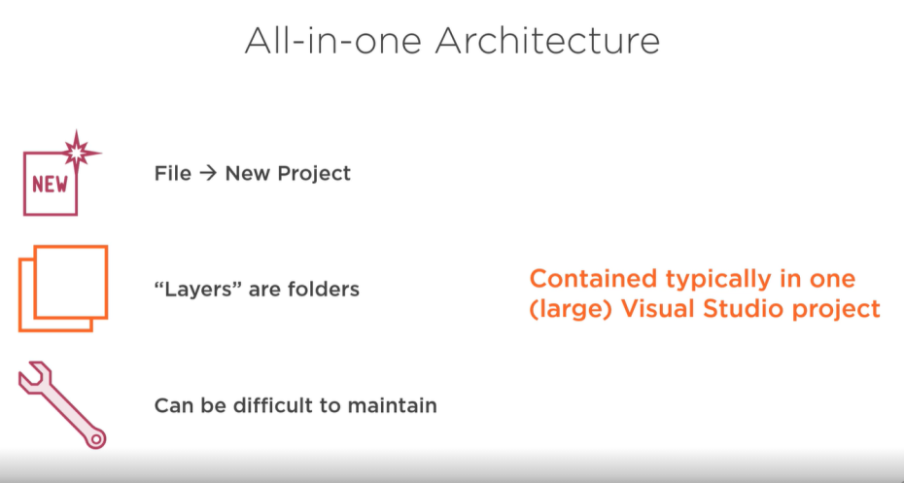

Each project generated in VS but add new, never used in professional environment!

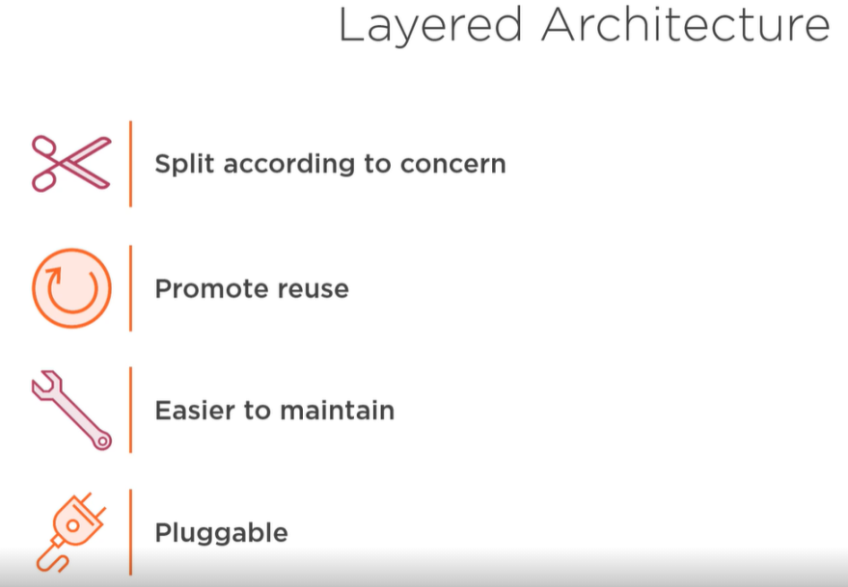

Standard MVC approach, but it can be divided on application or folder There are three layers:

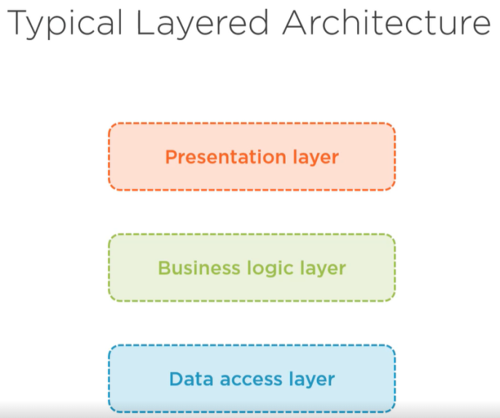

## Clean Architecture

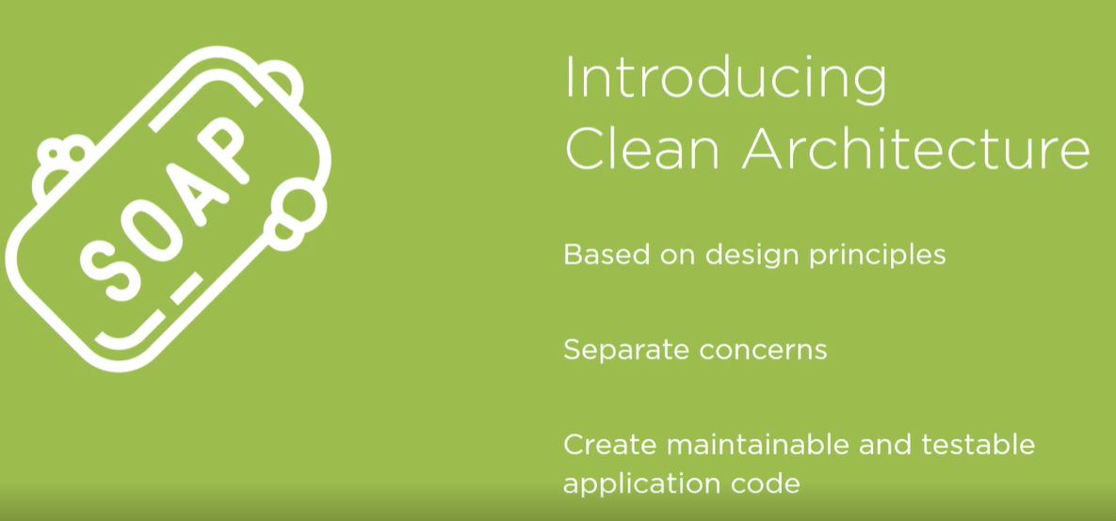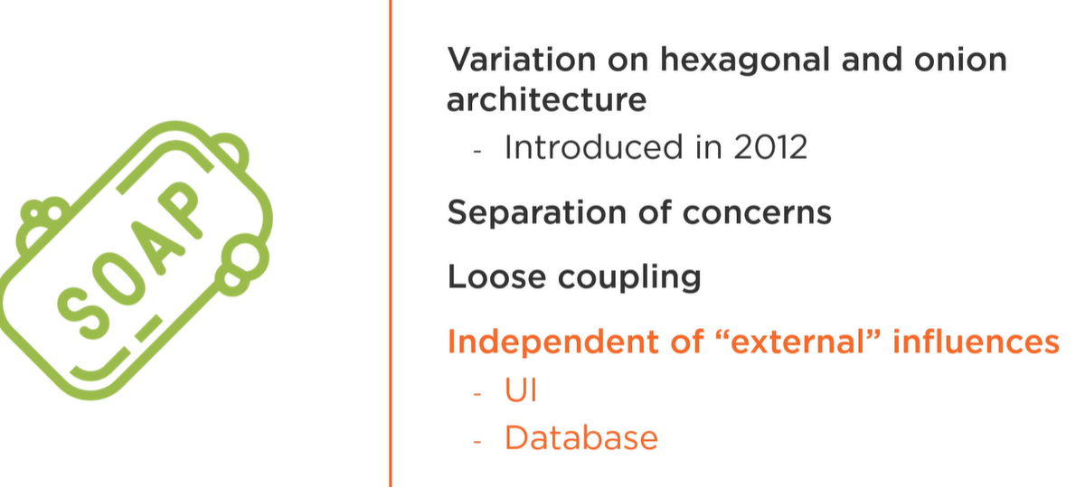

Application are connected via references but not all project has reference to rest. Only specific which is responsible for connection an use that operation from another project has a reference to.

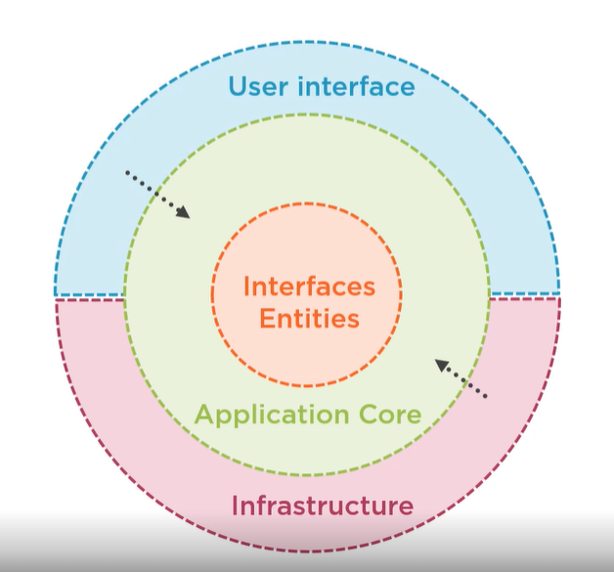

Clean architecture is based on abstraction and fifth principle from solid. Two first layers (Interfaces Entity and Application Core) are our application Core ☺ (the best sentence ever). This two parts has model of entity and interfaces of repositories to connect with an db. Then to these two are added a infrastructure which implement an interfaces to particular db and situation. Last layer is UI which use model and business layer (application) with services to make an operation an display data in view or send via endpoint. UI and Infrastructure can be detached and attached a new one. These two layer is based on dependency inversion (used a classes from another layer).

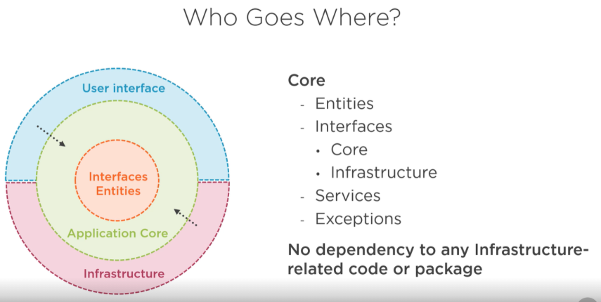

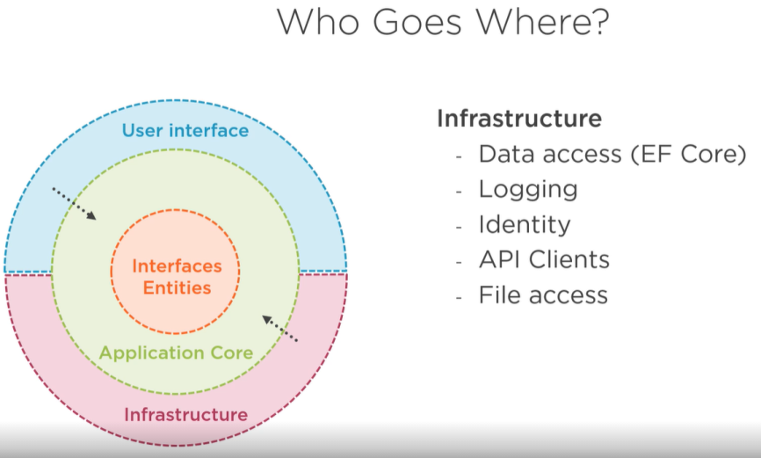

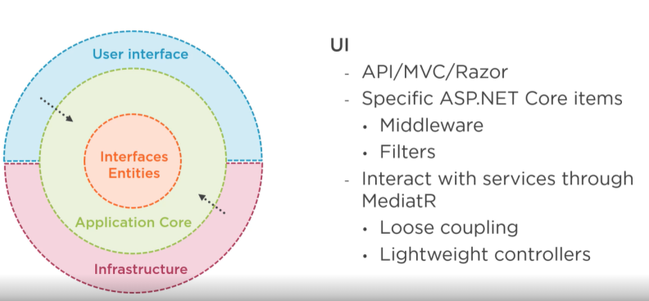

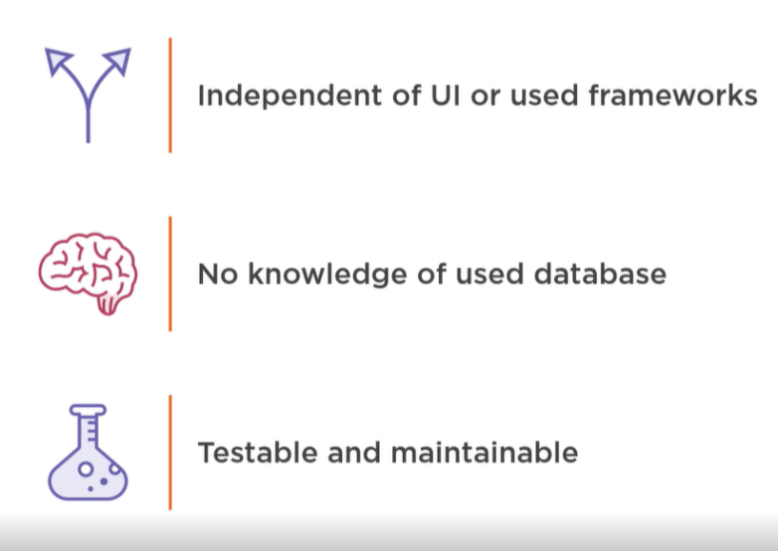

Benefits

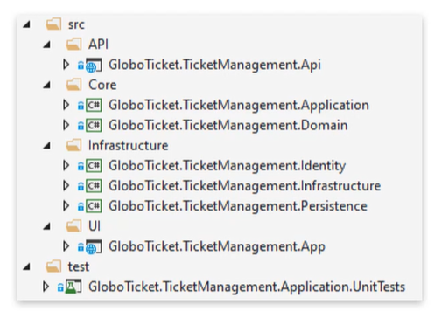

It looks like this above ☺

# Application Core

## Setting up application core

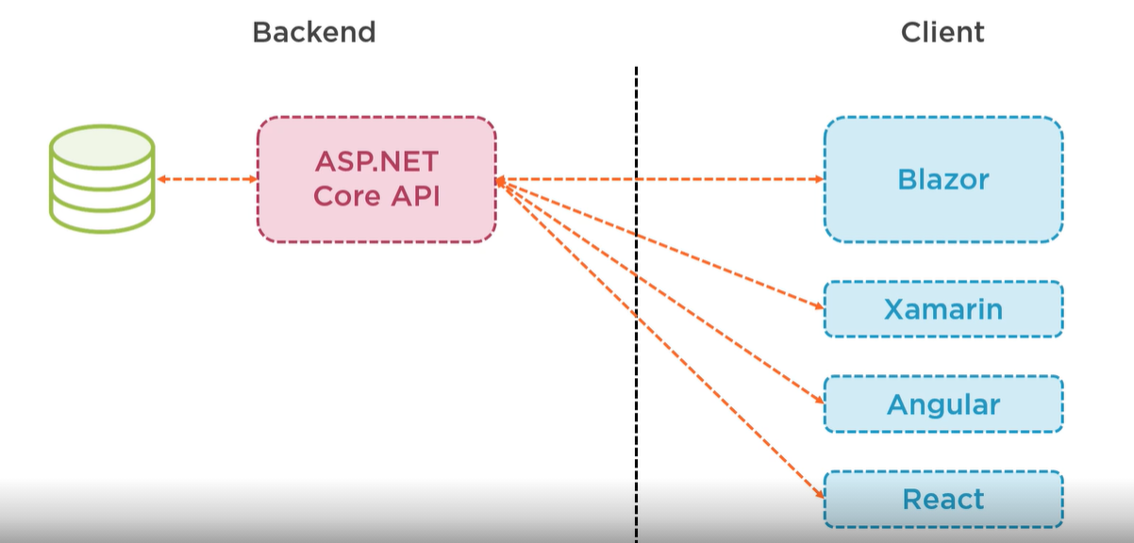

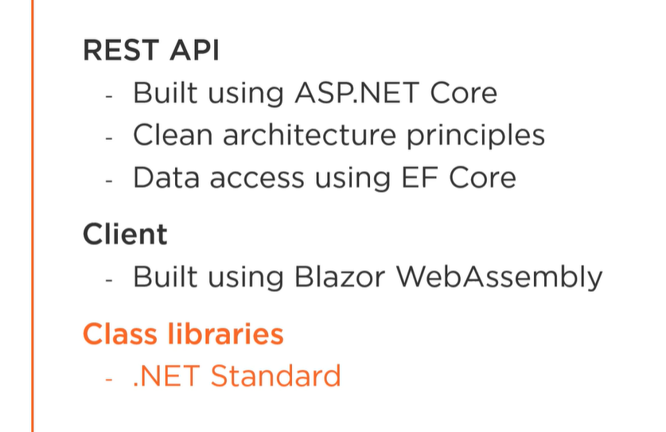

## Create an application

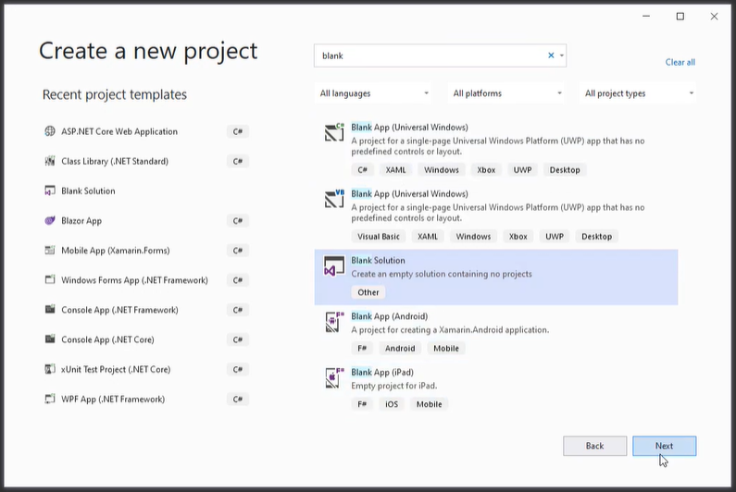

Create a blank solution.

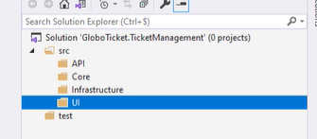

Prepare couple of folders, each for an application layer.

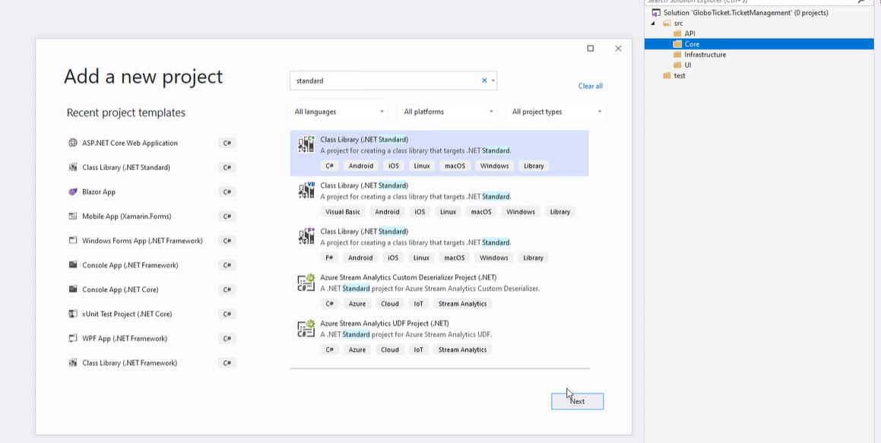

Now add core project - Domain. This will be a class library in .net standard framework.

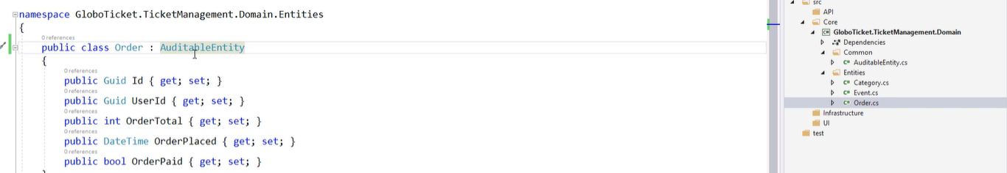

In domain project add entities and common with auditable data and inherit this properties to each entities.

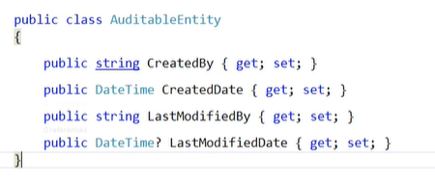

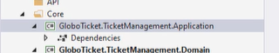

Now add application layer in core in the same way like domain.

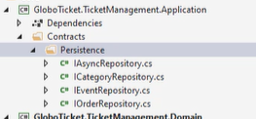

To this project add contracts and persistence (interfaces). Each of them inherit from IAsyncRepo.

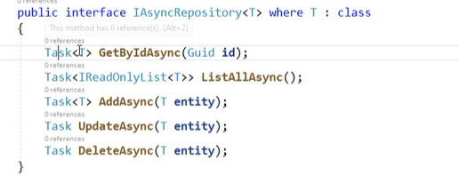

Generic type repository.

## Mediator pattern

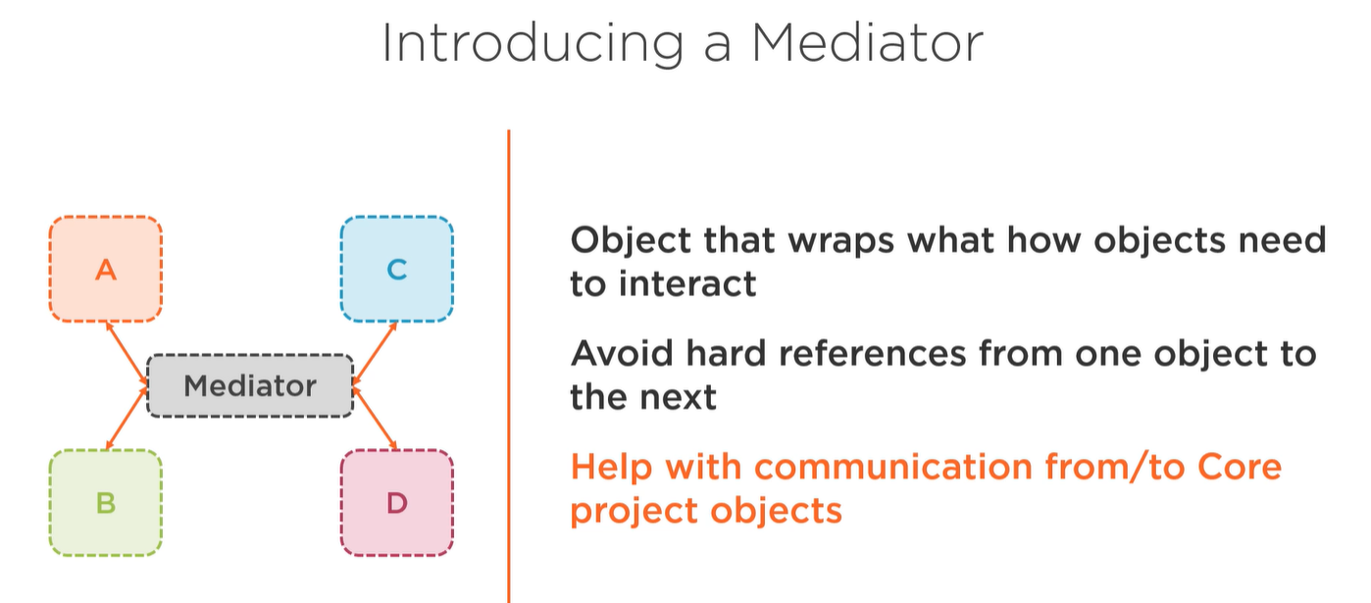

There is no hard references. all (projects) of them are connected by mediator.

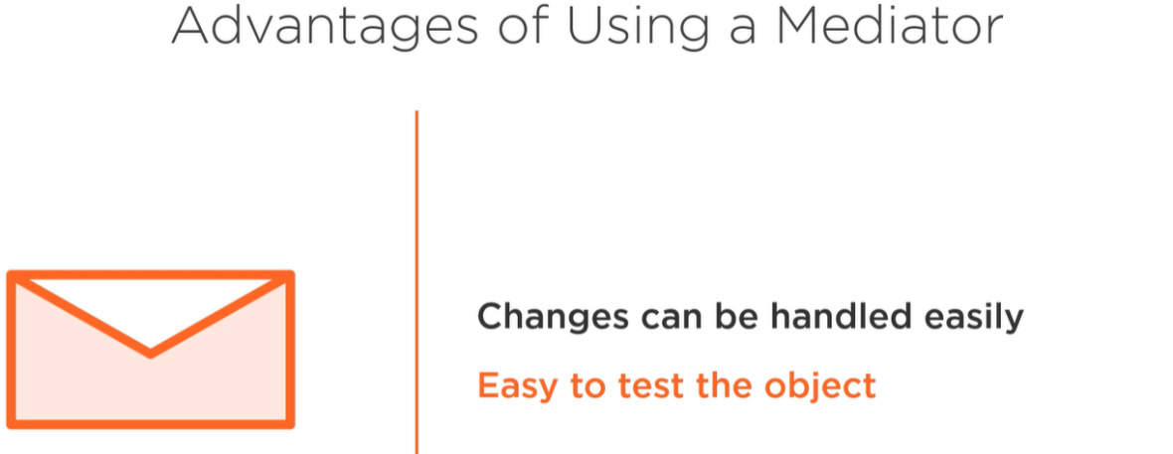

Change only in one place. Easy test because everything is isolated.

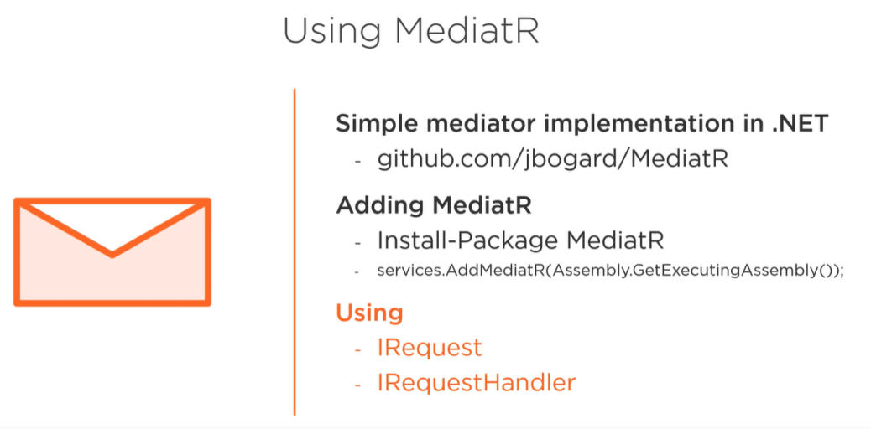

Set up. In MediatR are two interfaces. IRequest is used to wrapping an message (messages are used to communication) and IRequestHandler to do some action with particular message.

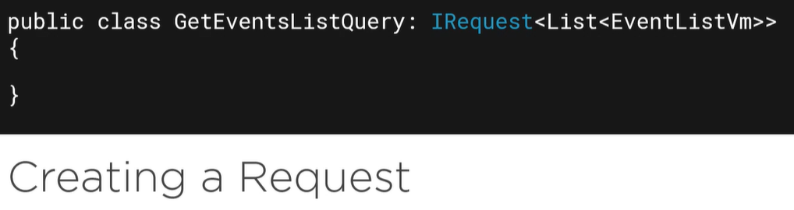

Basics implementation, don’t be scare it will be implemented in practice.

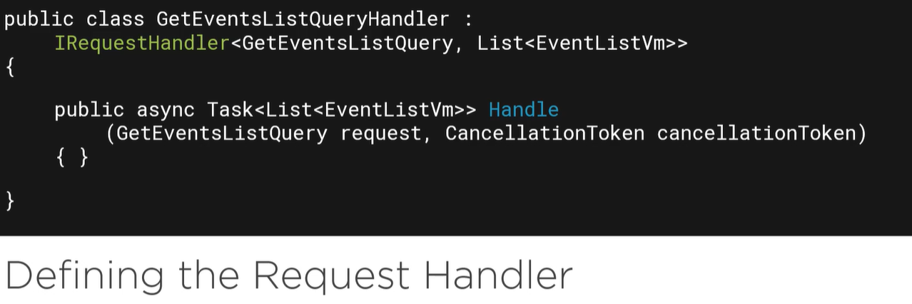

Do some things and again don’t be scare it will be implemented in practice.

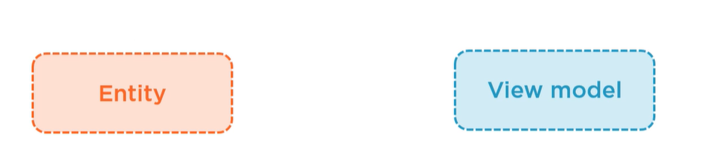

If you know what is one the picture add AutoMapper ☺.

## Implementation of MediatR and automapper

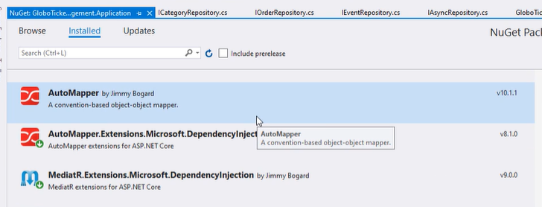

Install packages to your application project.



Add Query with IRequest which return a ListOfObject. It is a get all action.

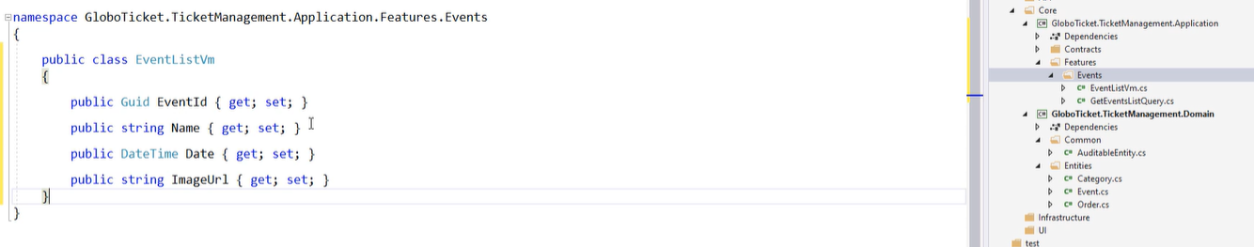

Add vm in the same folder.

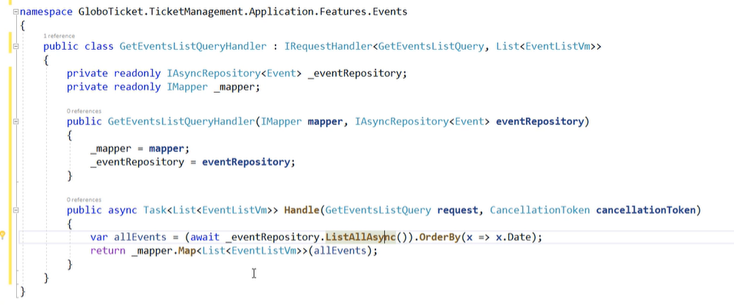

Add event handler in the same file. In this project is added AutoMapper. So we need a profiles.

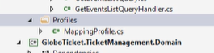

Create folder with MappingProfile class

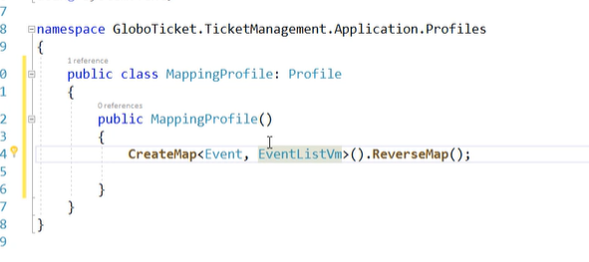

Add map with reverse.

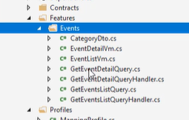

So let’s add more query for entity in the same way.

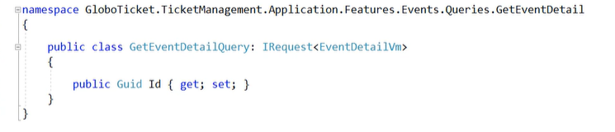

A query for details.

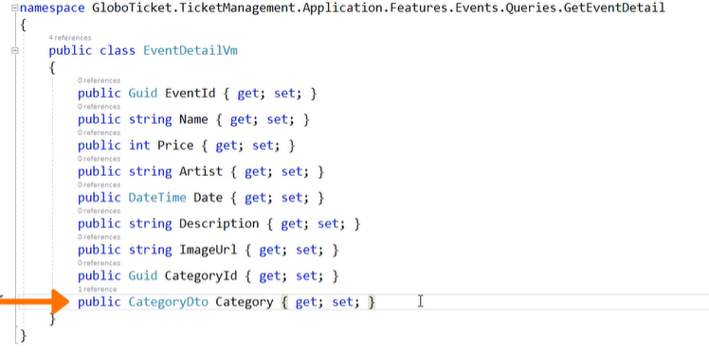

Add VM but remember all nested entity must be a DTO.

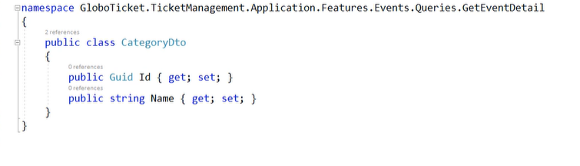

CategoryDto

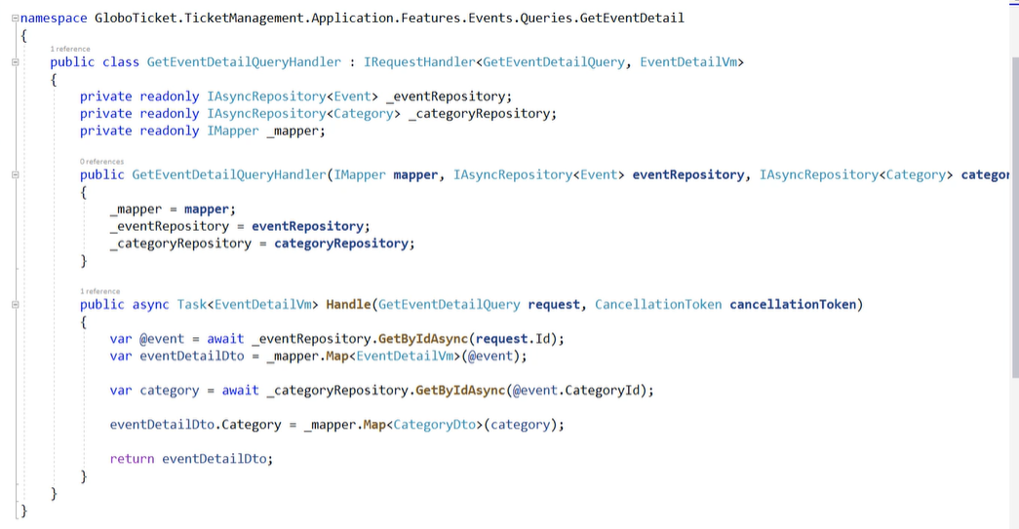

Request handler implementation each event mark with @.

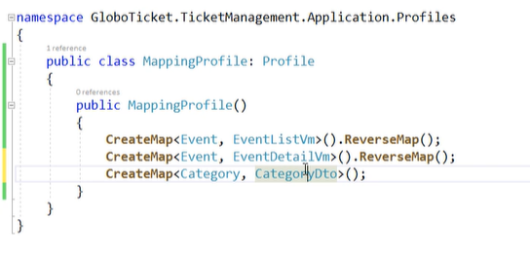

Add mapping for required VM and DTO.

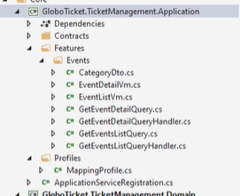

Add Application Service Registtration (Dependency injection class).

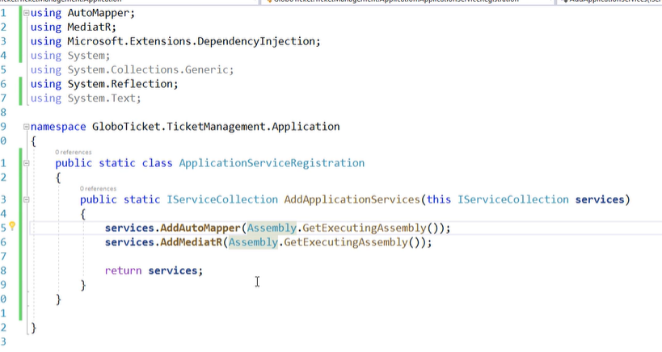

And implementation.

## CQRS

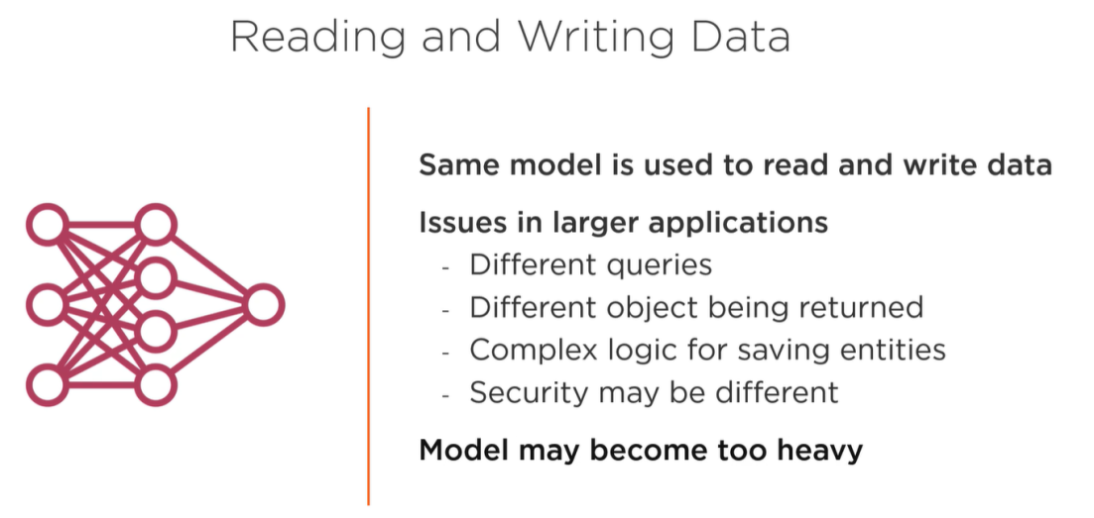

Each model to a lot of operation so CQRS is usefull to release some operation memory.

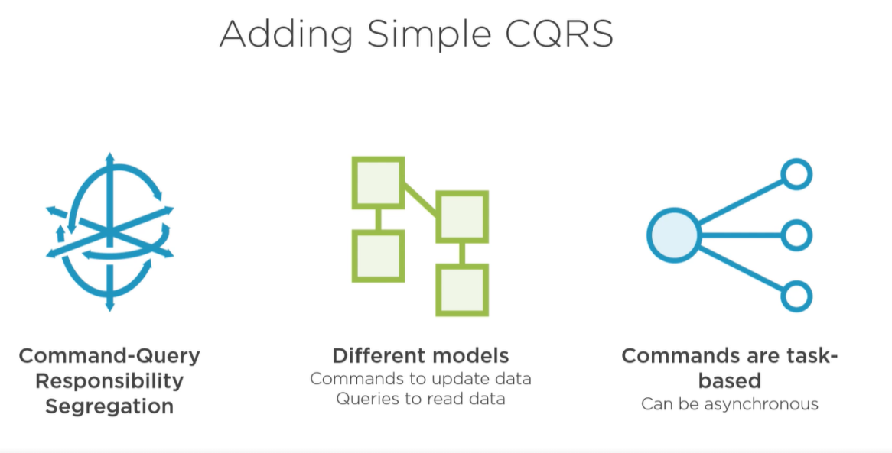

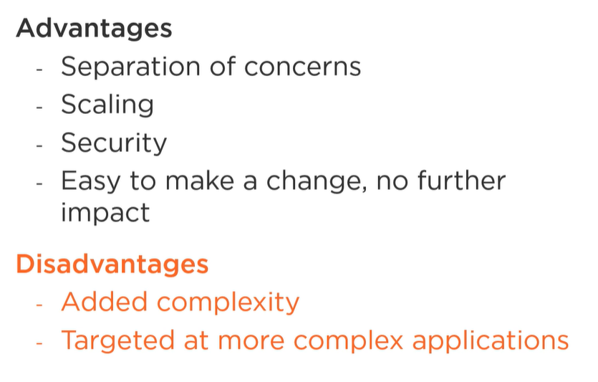

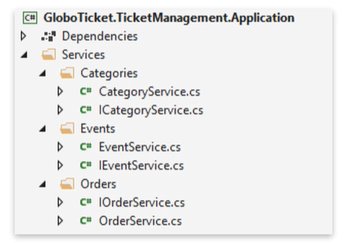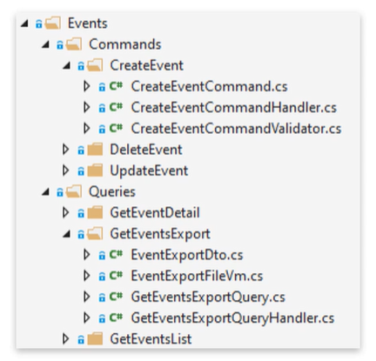

Feel the difference. First picture above is standard Services when we used interface and implementation. On the right side is a CQRS which has been divide to Commands and Queries Each action has own class. Let’s do in practice.

## CQRS in practice

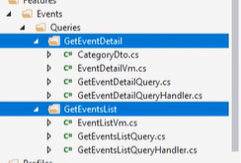

Lets divide Events ro Queries and command. Each operation need to be segregate and keep in folder.

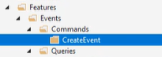

Then add Commands with create action.

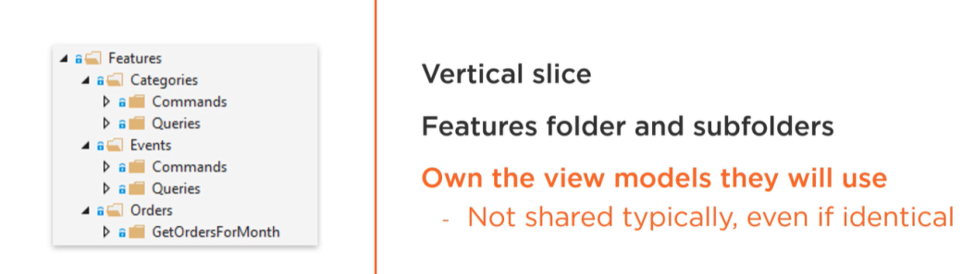

So this will be looks like this. Feature which is implemented here is a DDD. All Entity must be divided to folder and can’t be depended form another one.

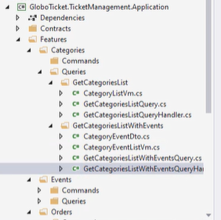

Added some more Queries to Categories.

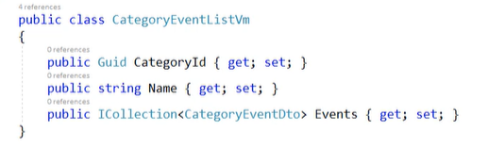

Category has relation with Events.

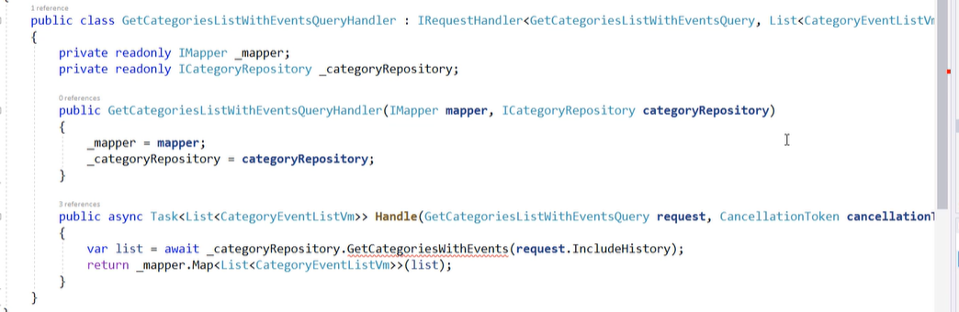

First time is used a specific repository not an Async<T>.

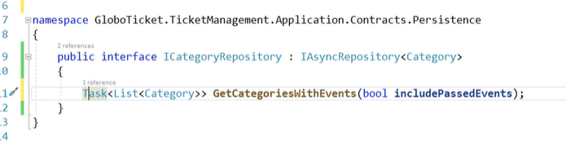

ICategoryRepo is extension of AsyncRepo.

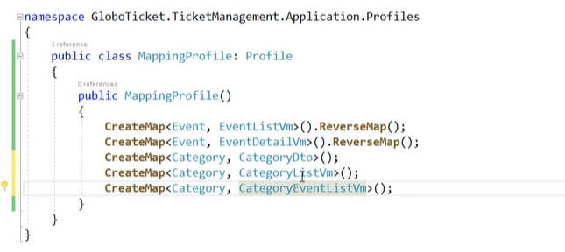

And of course add mapping.

## Command

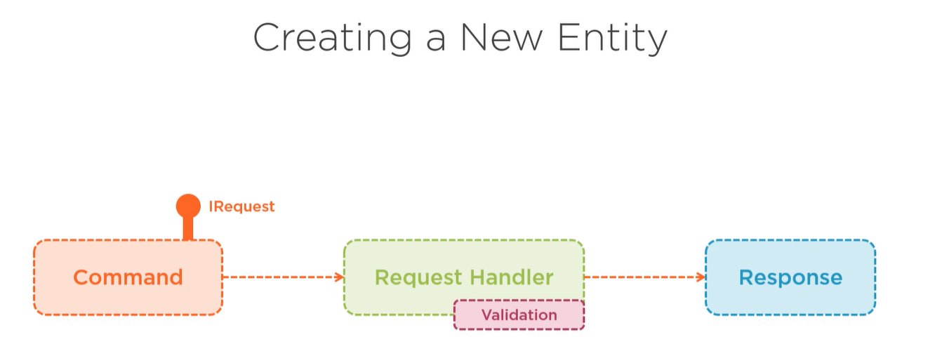

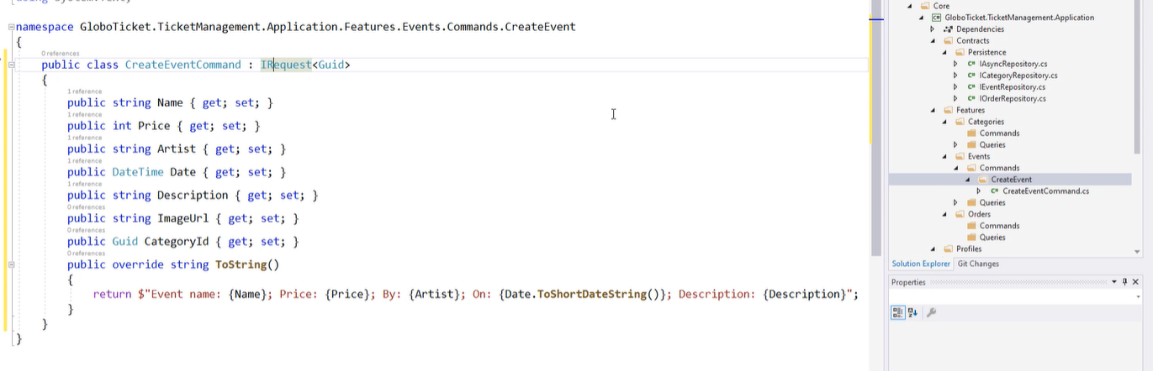

Lets create a new Command. It is a CreateEvendCommand

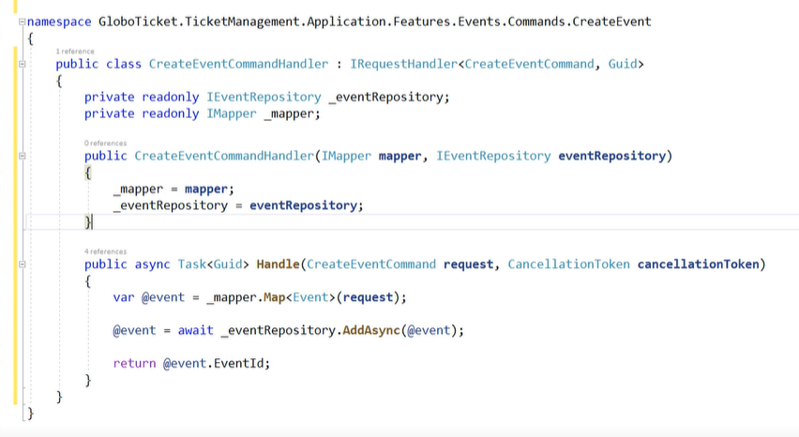

Implement and event handler.

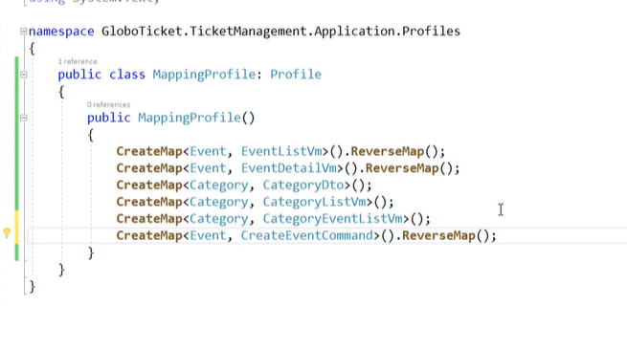

Add mapping

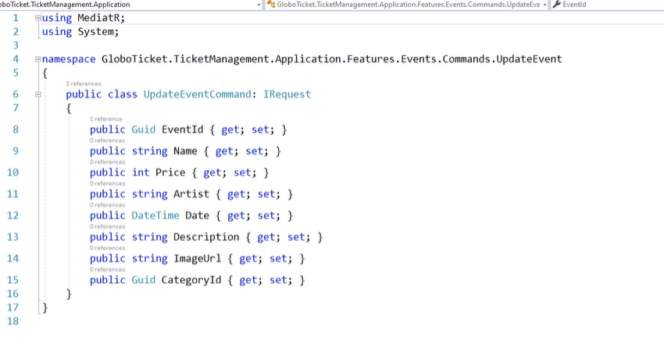

Update command works in the same way. Create a model for update.

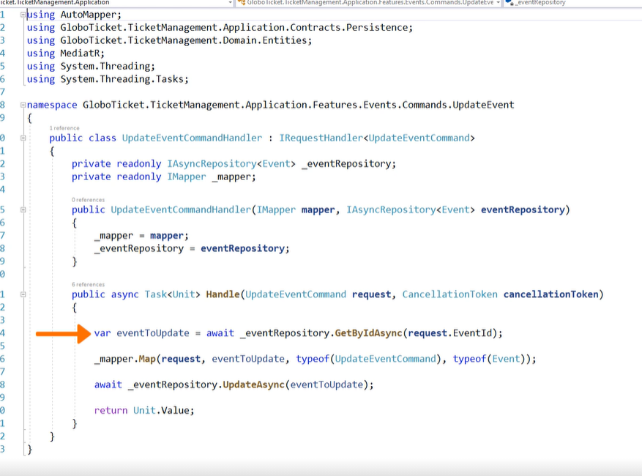

Implement event handler.

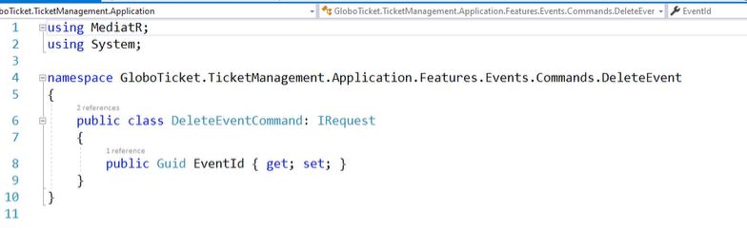

DeleteComand required only an id.

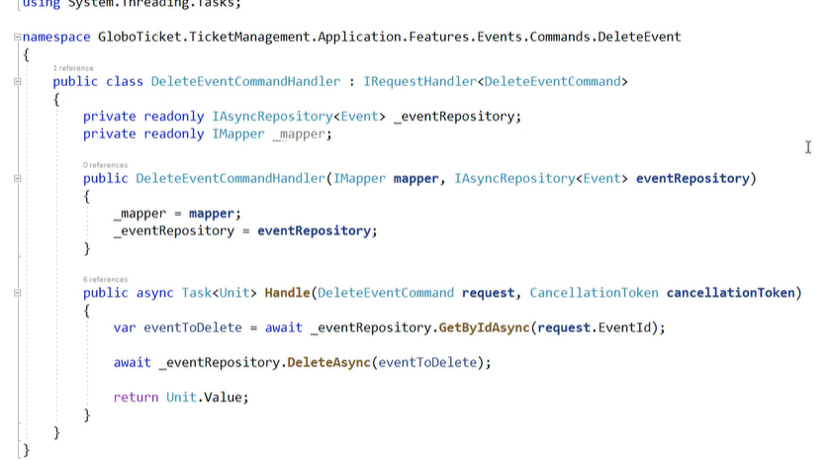

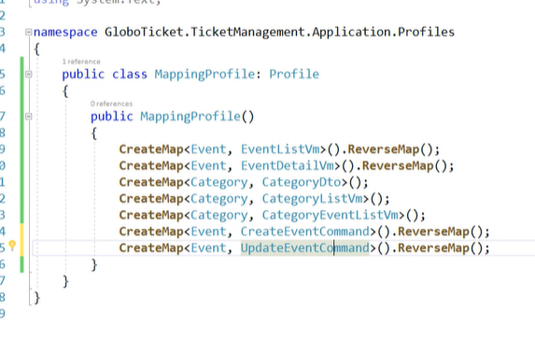

Of course remember about mappings.

## Validation

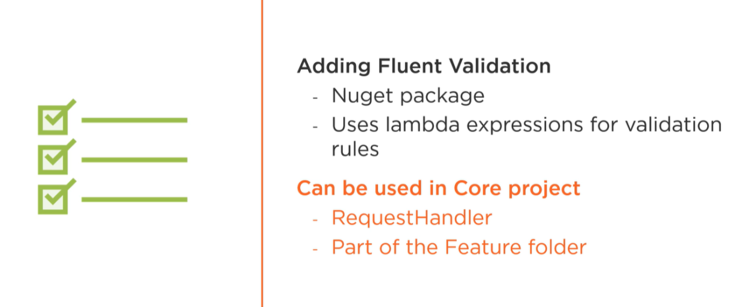

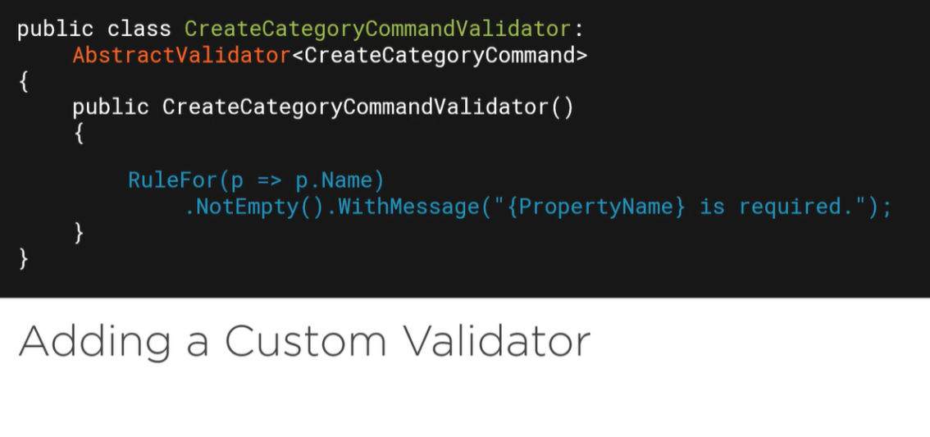

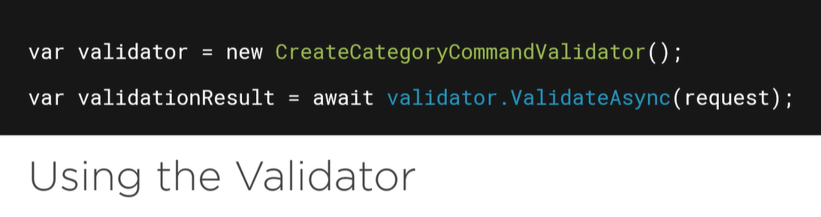

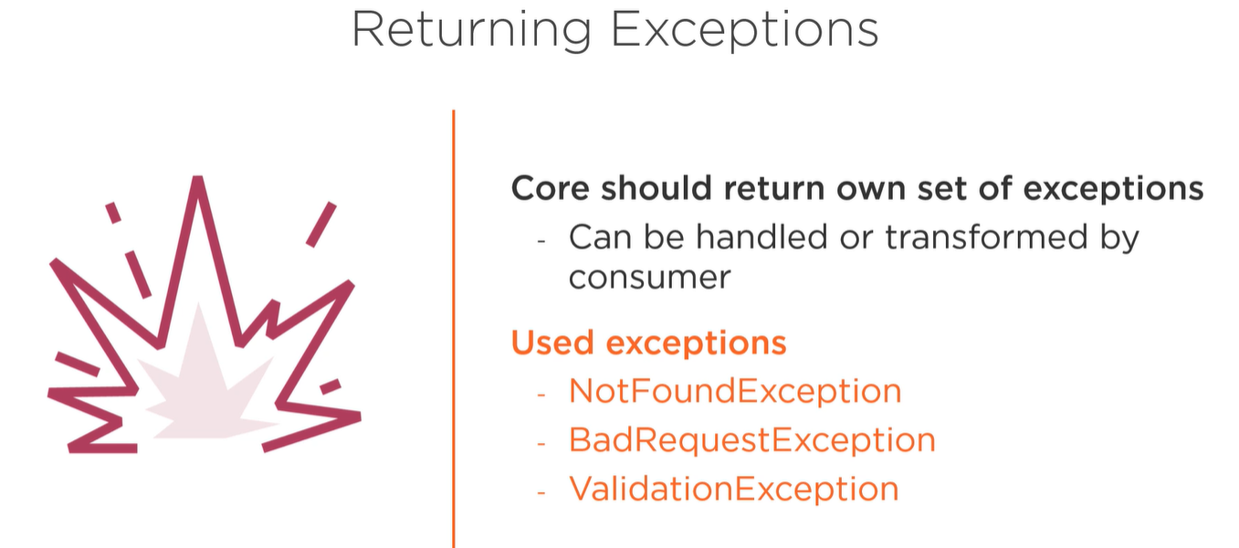

Validation should return there own exceptions.

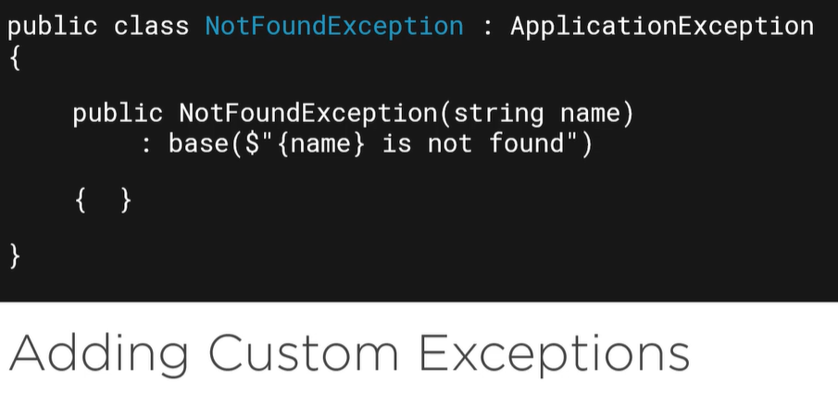

## Add validation

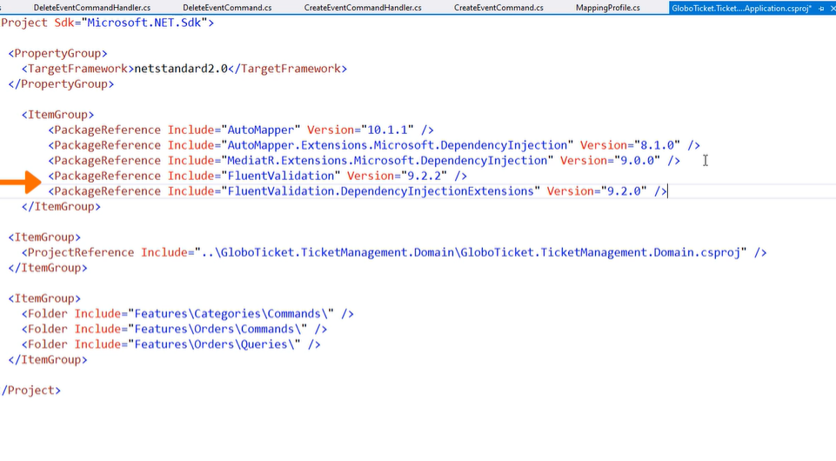

Add fluent validation to application project.

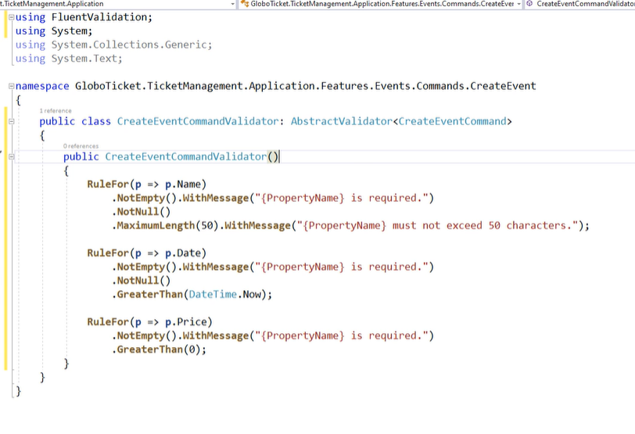

Know create an CommandValidator. This one above is for CreateCommand.

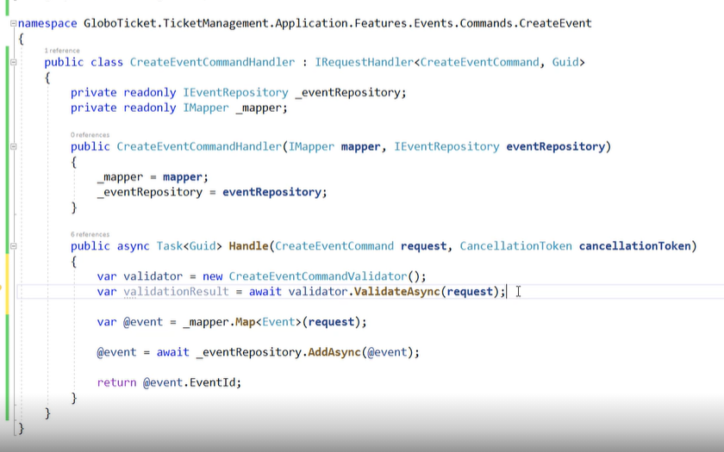

Now add validation rules for eventHandler, but if something gone in wrong way, program need return an exception.

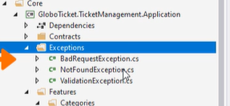

So add exception for folder designed for it.

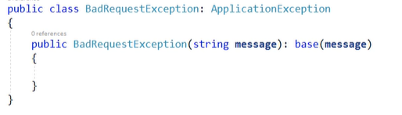

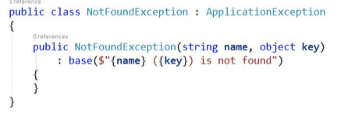

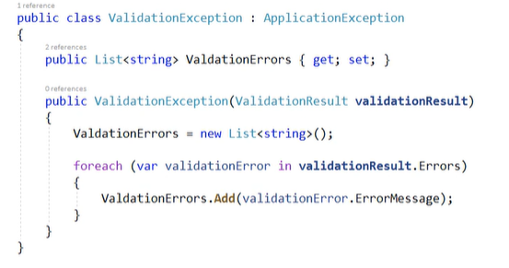

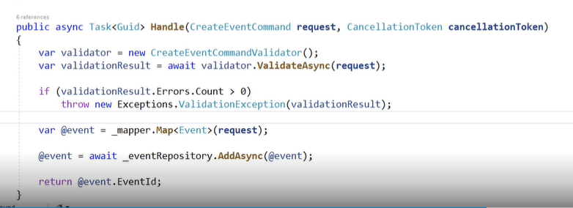

Implement validation in handler. First one ValidationException.

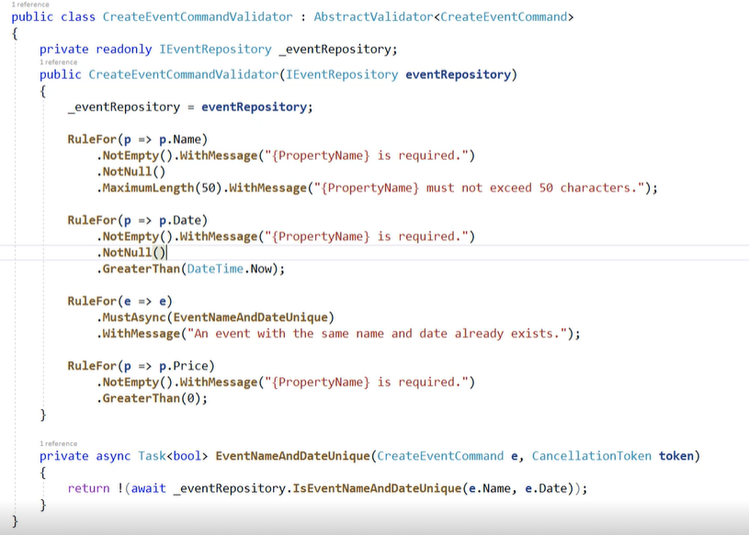

Add a new rule each event must be unique.

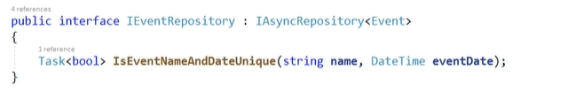

Remember to add validation method to repo.

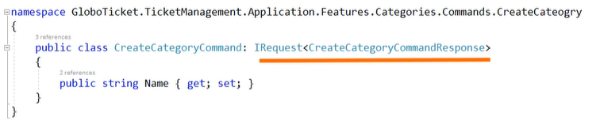

Lets create CreateCatogoryComand with IRequest <CreateCAtegoryCommandResponse>

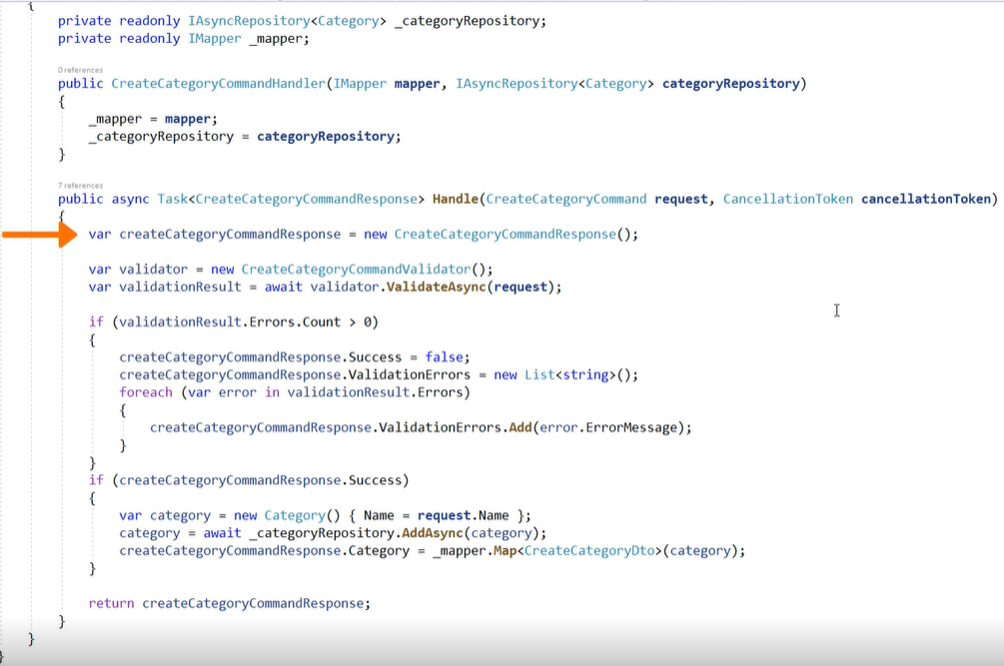

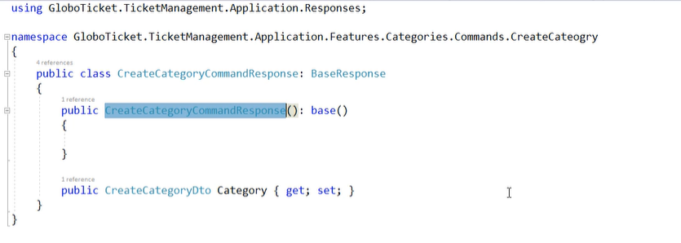

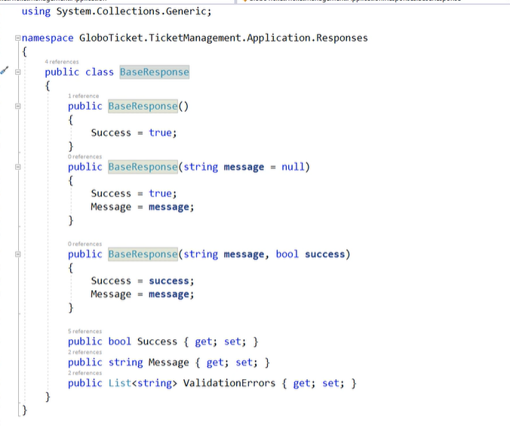

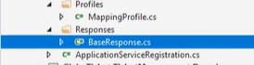

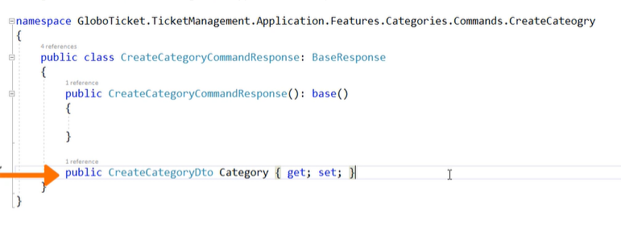

This make a full response of validation and action. This is the best way to invoke a command.

# Infrastructure

## Description

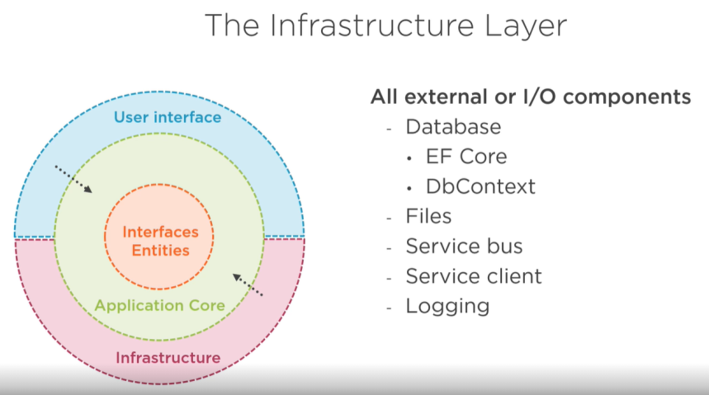

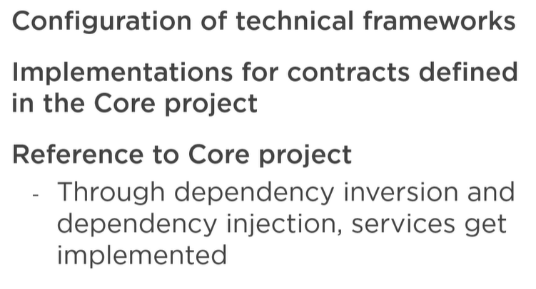

## Data Persistence

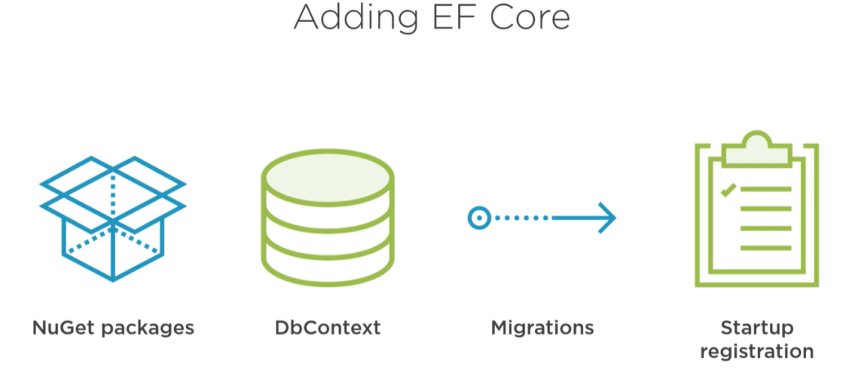

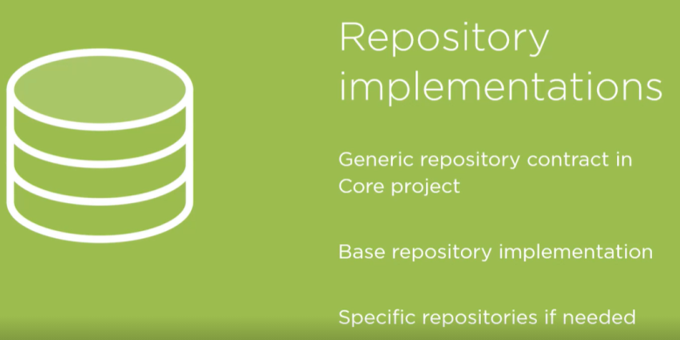

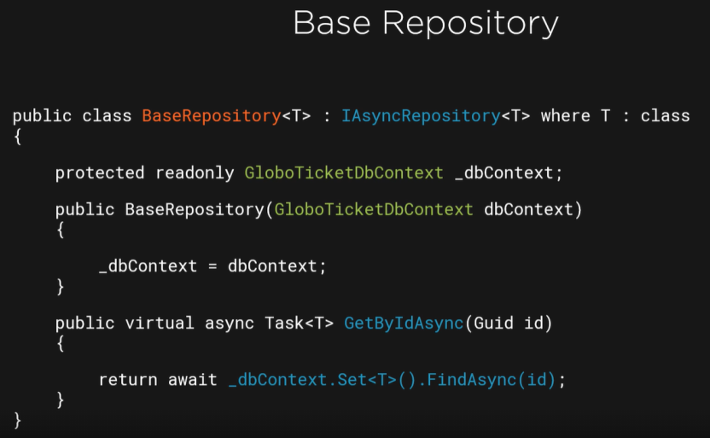

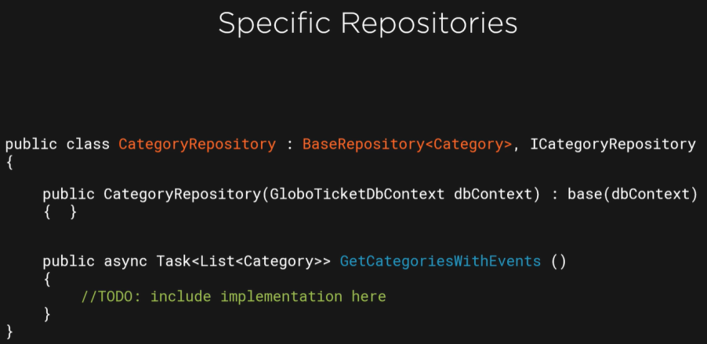

## Persistence in practice

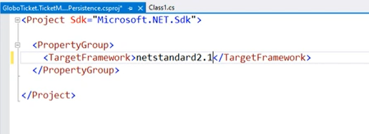

Create project for persistence in infrastructure.

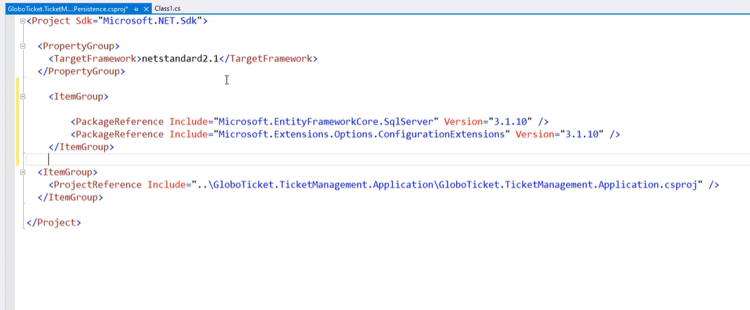

Then include reference to application and add entityframework and MS.Extension.Options.ConfigureExtension.

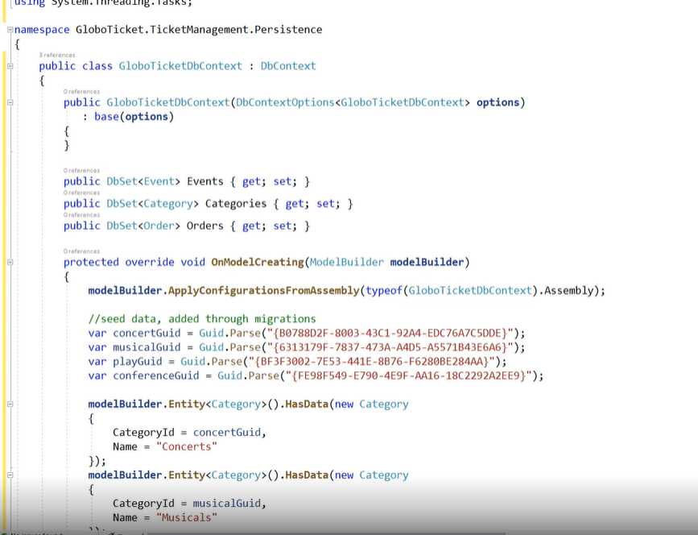

Add DbContext with seed in onModelCreation class.

Look on method ApplyConfigurationFromAssembly. This method retrieve configuration from Assembly (Persistence project) look under.

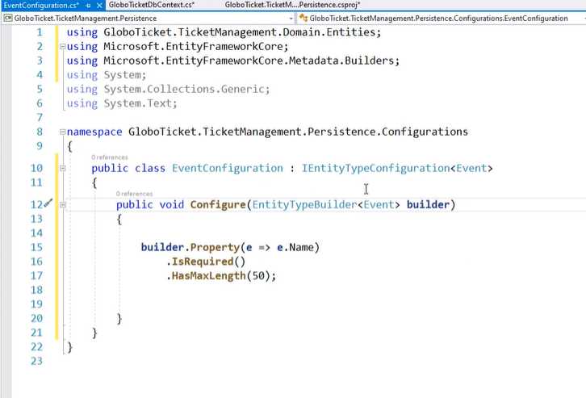

Each configuration required IEntityTypeConfiguration<T> interface. When you mark and implement configure method, configuration will be added to DbContext.

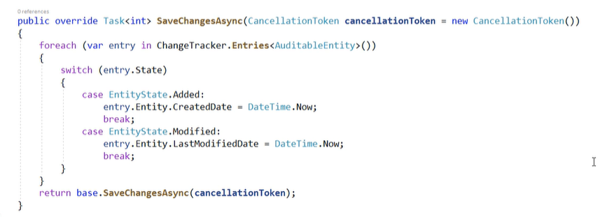

Last modification is SaveChanges method which set all DataTime and looking for Modified entities via tracker.

## Repositories implementation

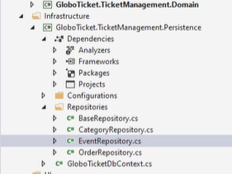

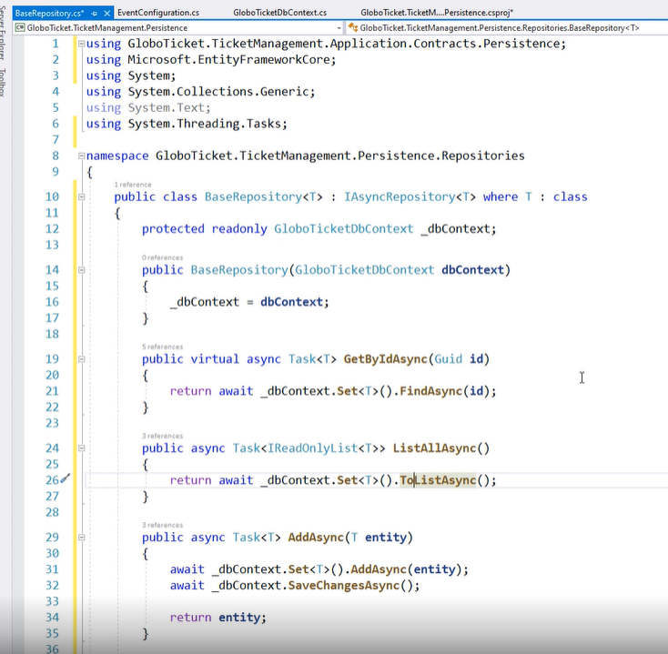

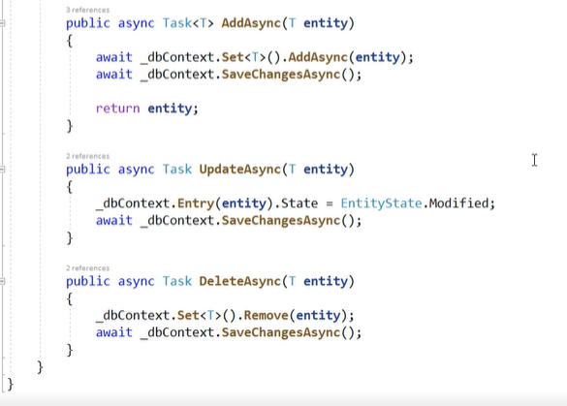

First is BaseRepo, a IAsync<T>. Implementation is a normalCrud with tracking.

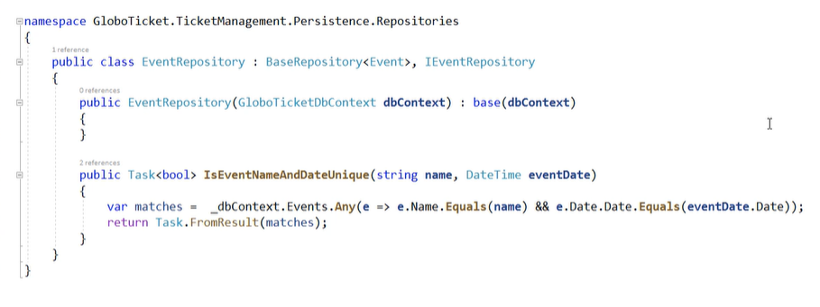

Now let’s implement more specific repo.

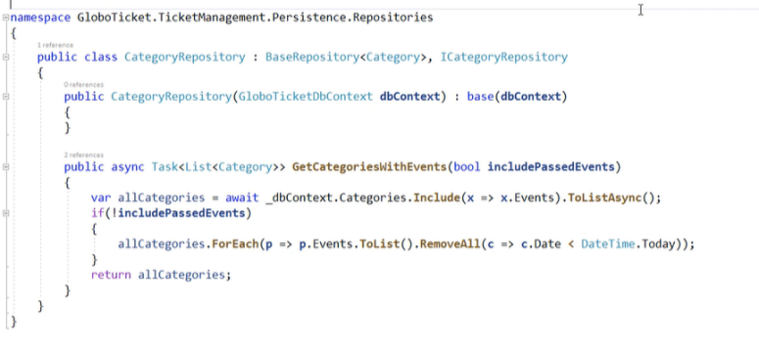

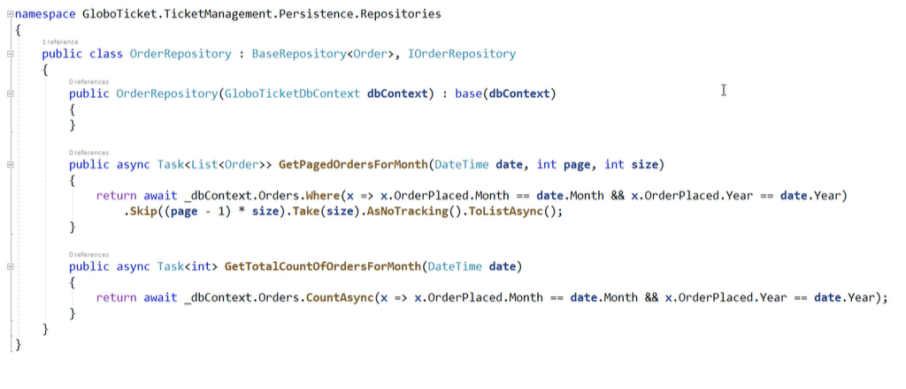

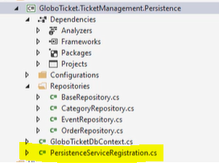

Now add PersistanceService (class with DI).

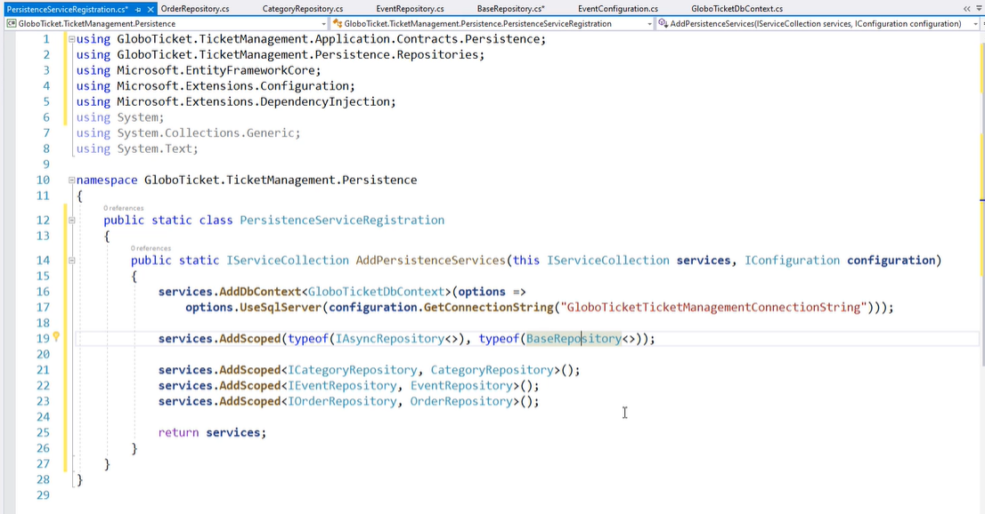

## Add SendGrid

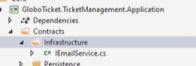

Add IEmailService in Application

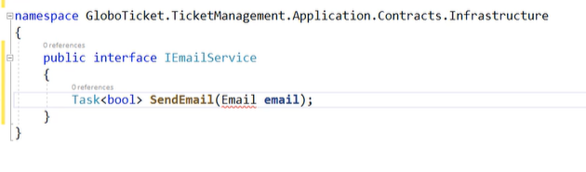

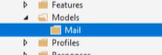

Add model with Mail model.

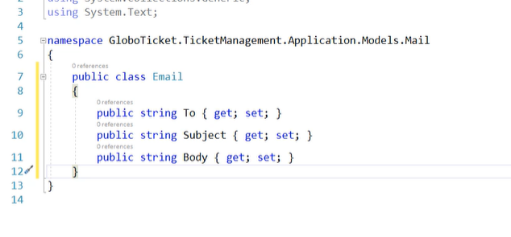

Add properties.

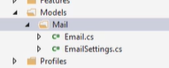

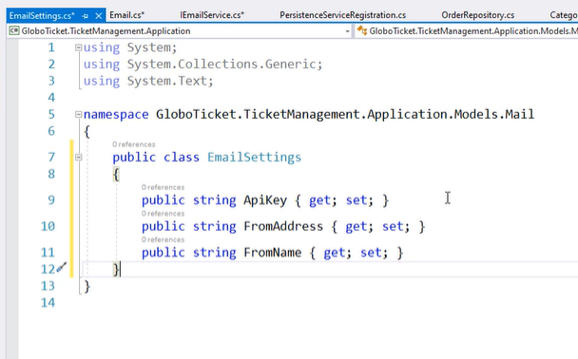

Add EmailSettings

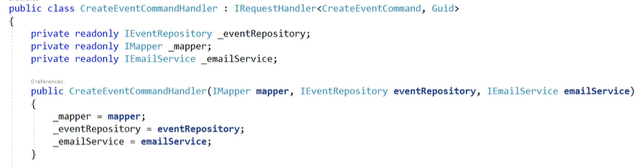

Inject email sender.

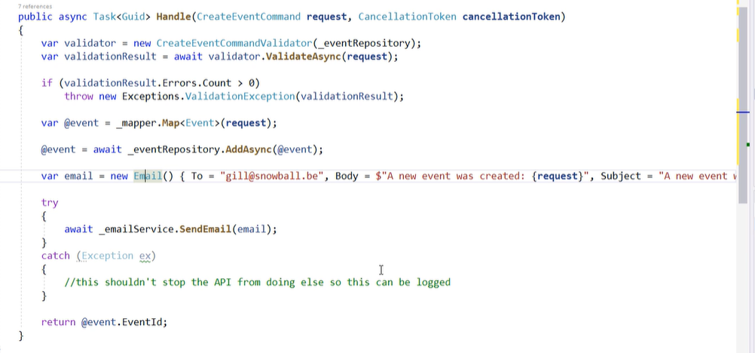

And in handle sendEmail in Try catch block.

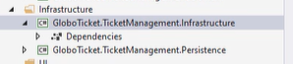

Add new project in infrastructure.

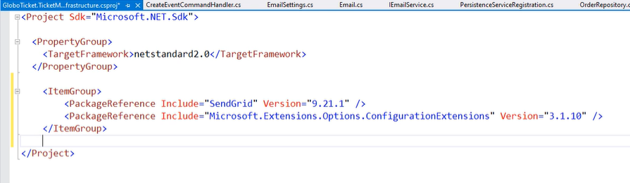

Add some packages Sendgrind and MS.ConfigurationExtension

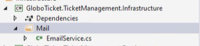

Implement service

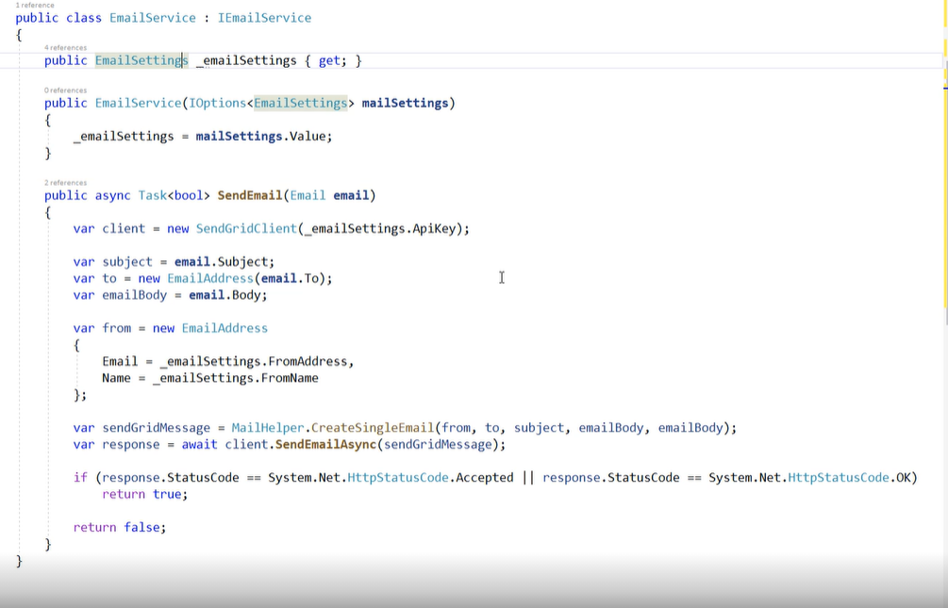

Add SendGridClient with implementation.

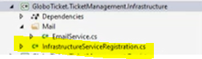

Add registration.

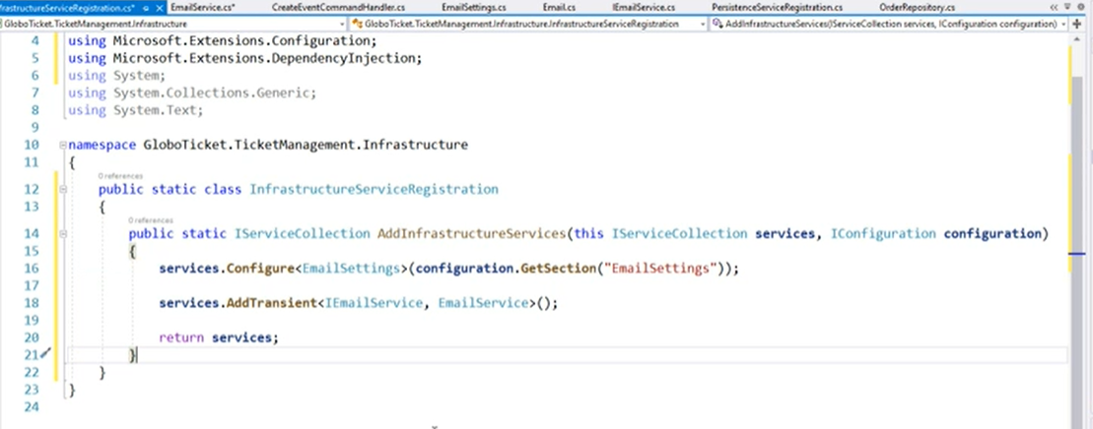

And Inject classes. Infrastructure project has been done.

# API

## Introduction

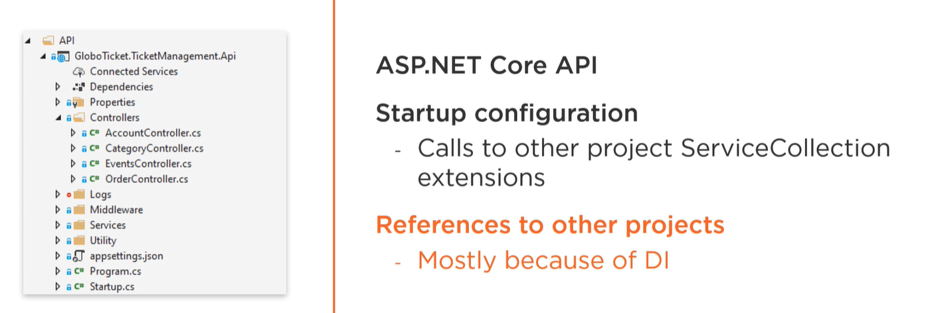

## Create Project

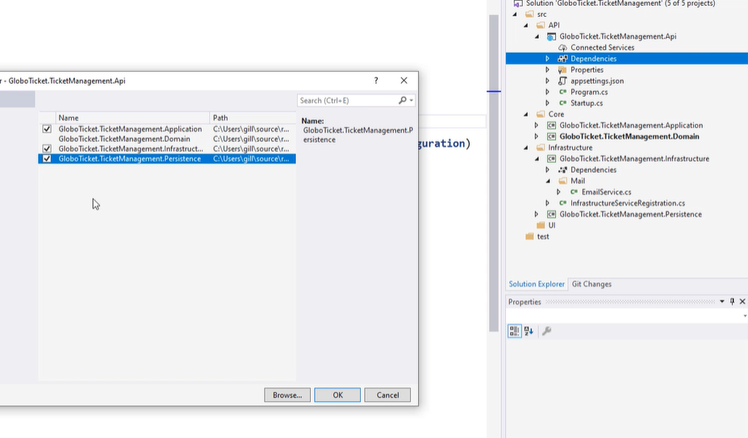

Create API project and add references to all layers except Domain.

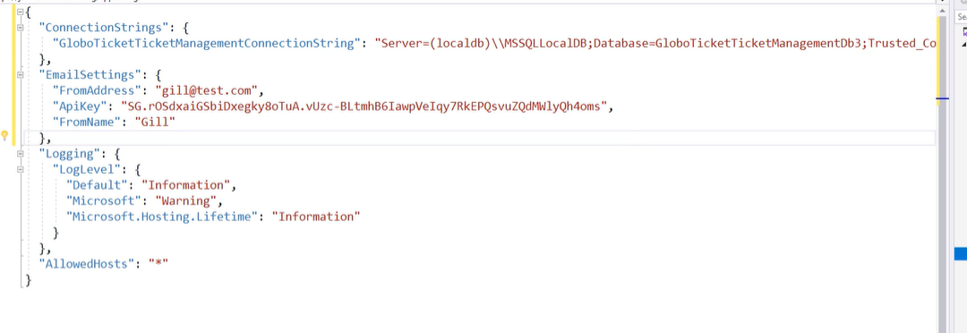

To appsettings add ConenctionString and EmailSender configuration.

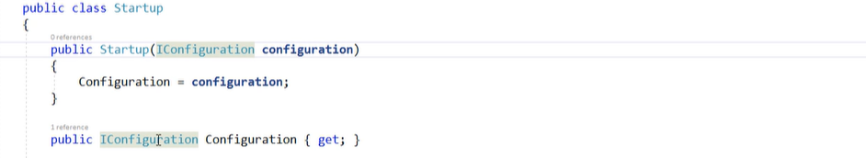

In startup inject Iconfiguration

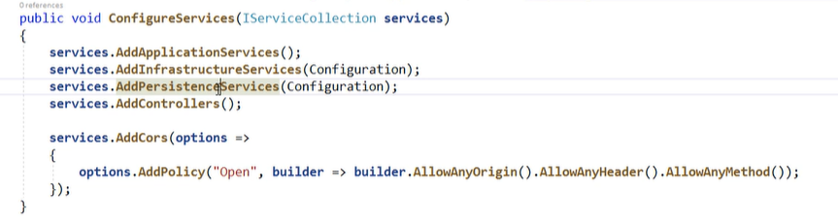

Then inject all required classes and add controllers.

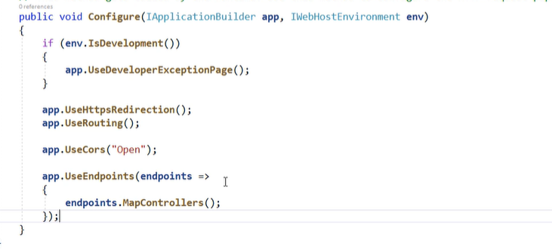

Configure middleware add routing, redirection, cors and endpoint.

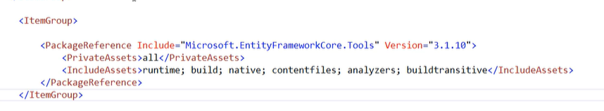

Add package for migration.

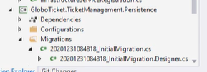

Then add migration ro Persistence project and update-database.

## Controller

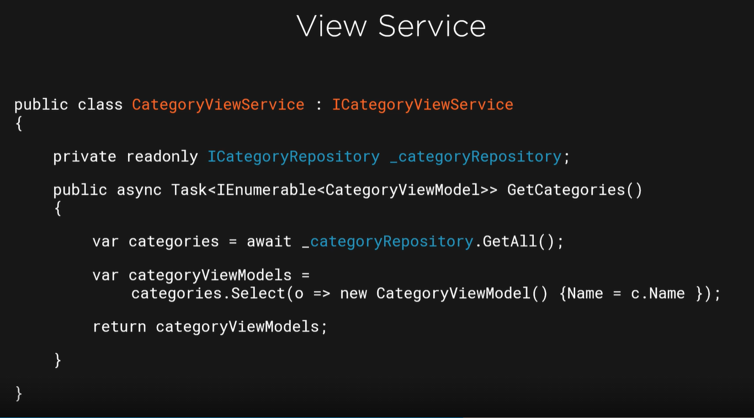

In CleanArchitecture controllers use ViewService.

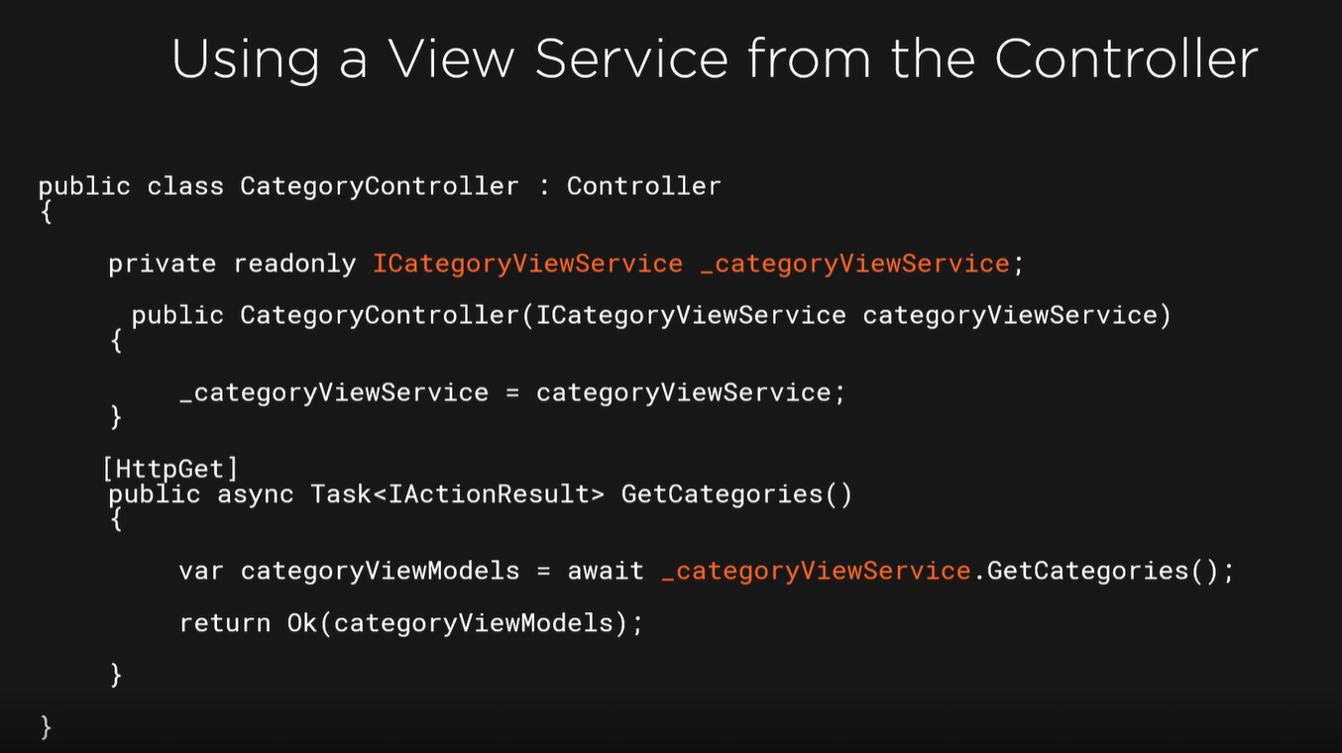

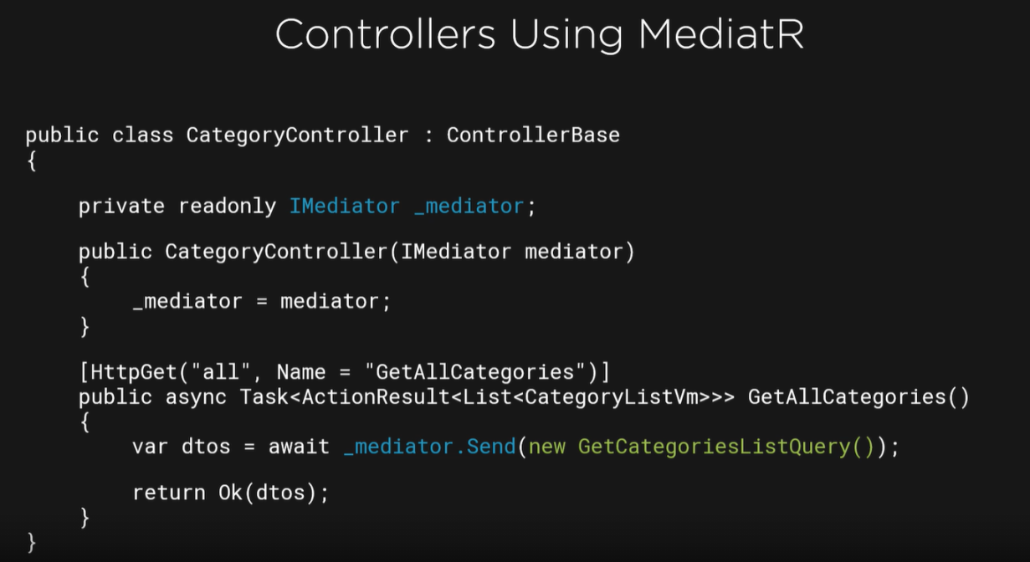

But it is a better way to do operation in controller. Let’s implement MediatR ☺

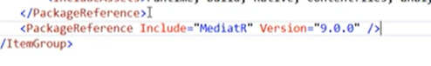

So add this magic package.

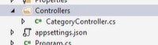

Create controller

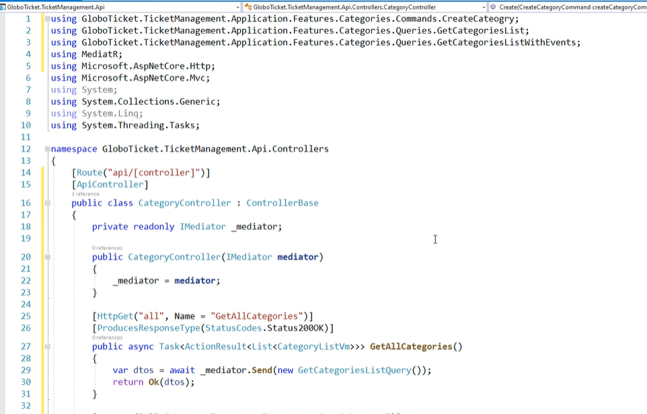

Inject a MediatR

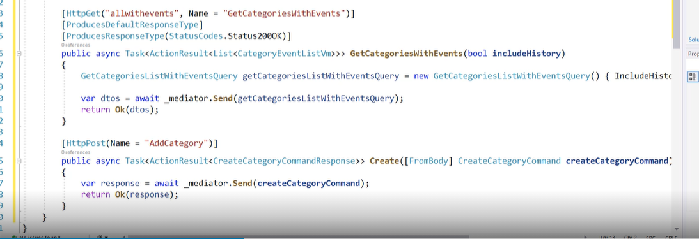

Mediator send a message to request which implement a IRequest interface and get a result dtos. Each request is handle by IrequestHandle and handle method after tahat metol has been invoked result is retrieve in controller and send with status code.

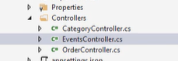

Implement a rest controllers.

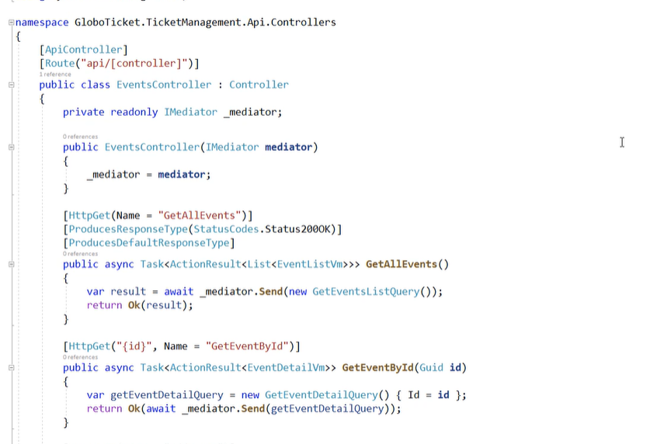

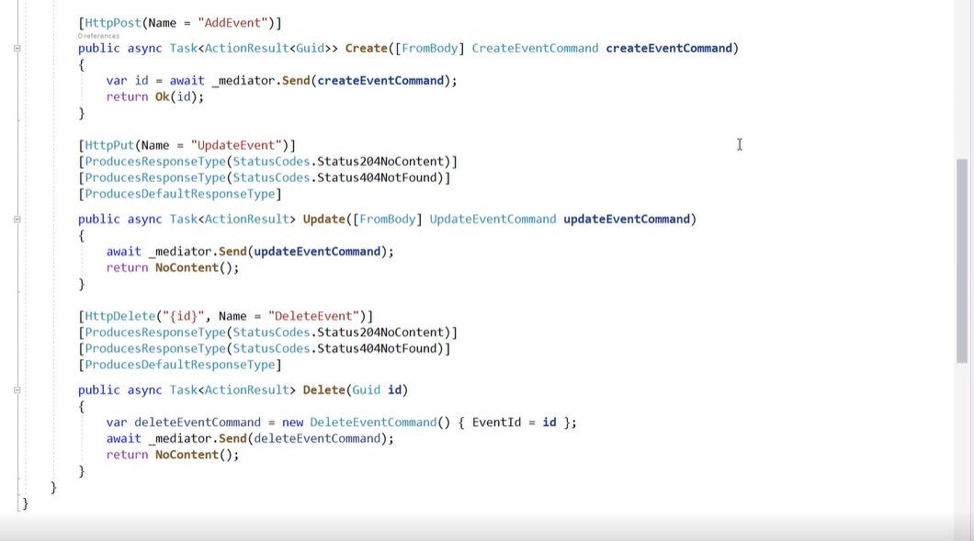

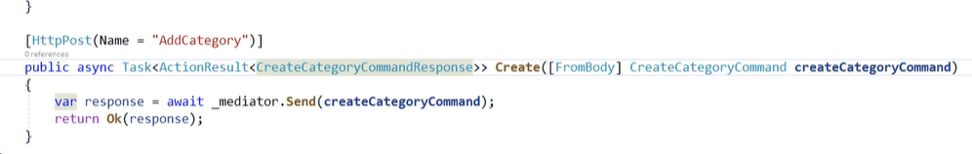

Remember all query returns DTO all Command return response.

## Return File

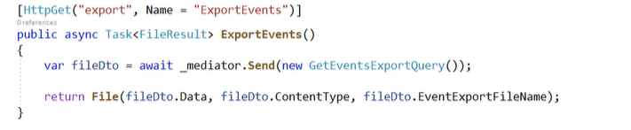

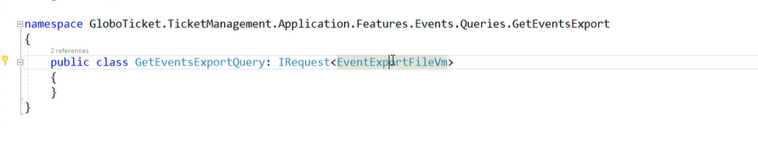

Add Query

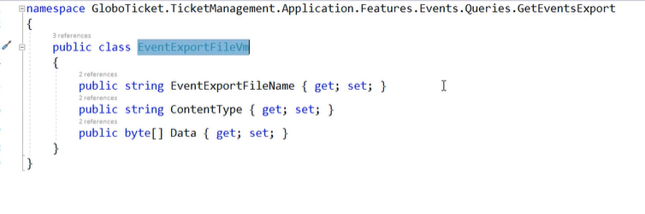

And Type.

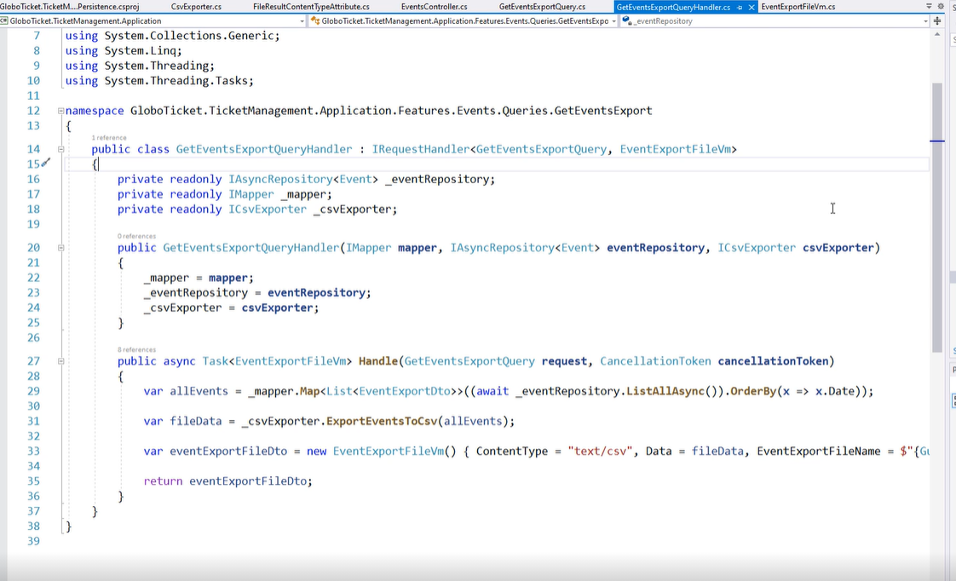

Add handler

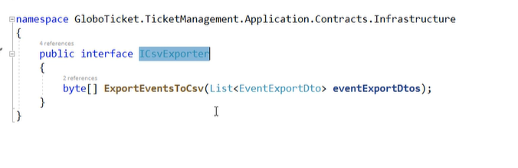

And interface which I used in handler

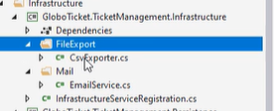

In infrastructure add CsvExporter.

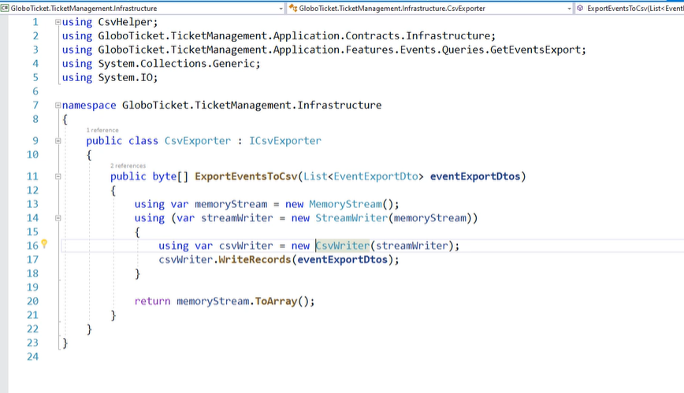

Return file as byte stream.

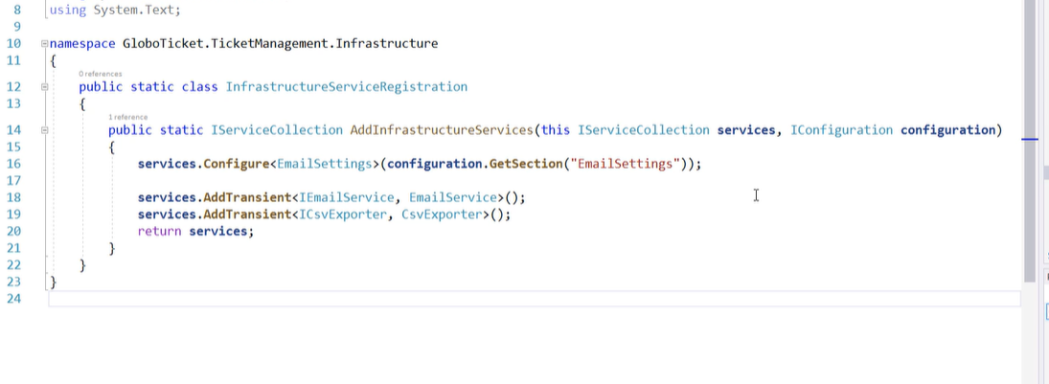

And register class

## Add Swagger

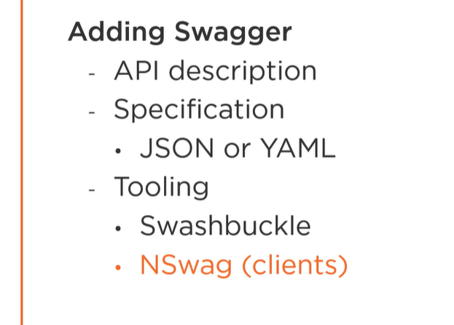

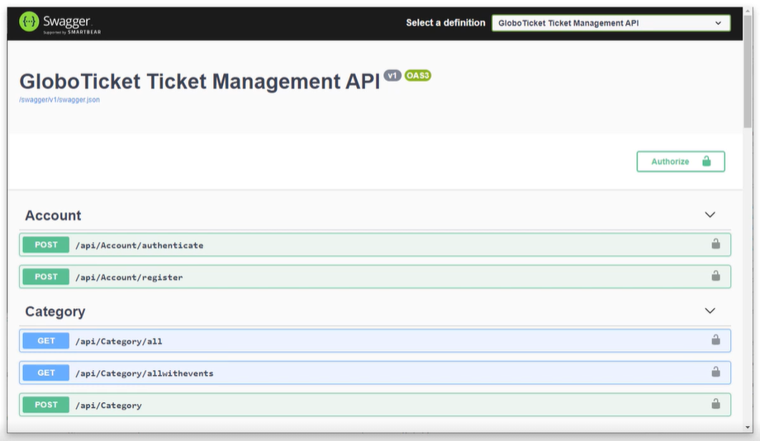

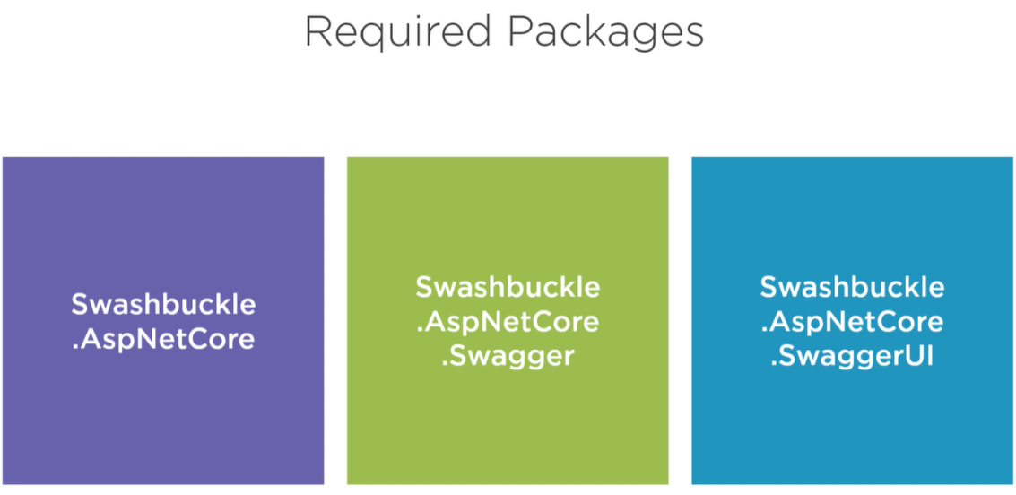

## Swagger in Practice

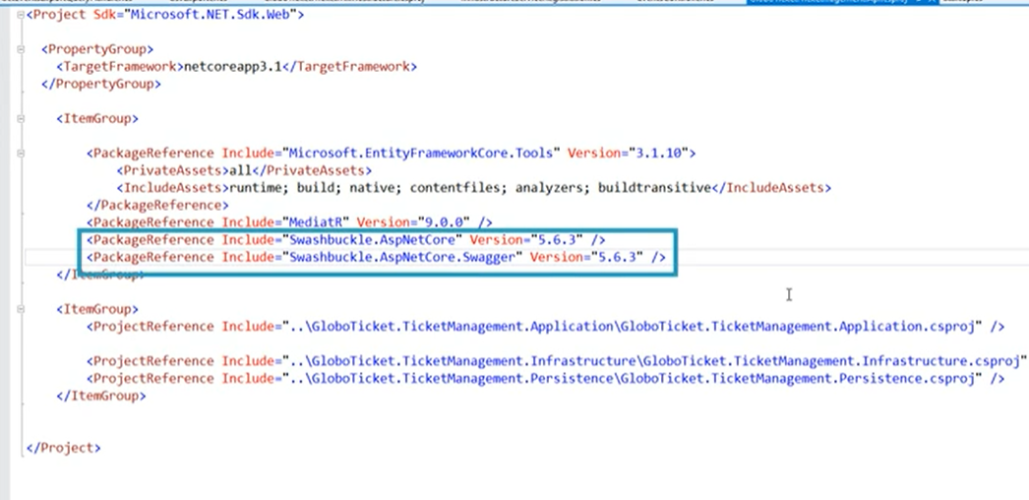

Add Packages

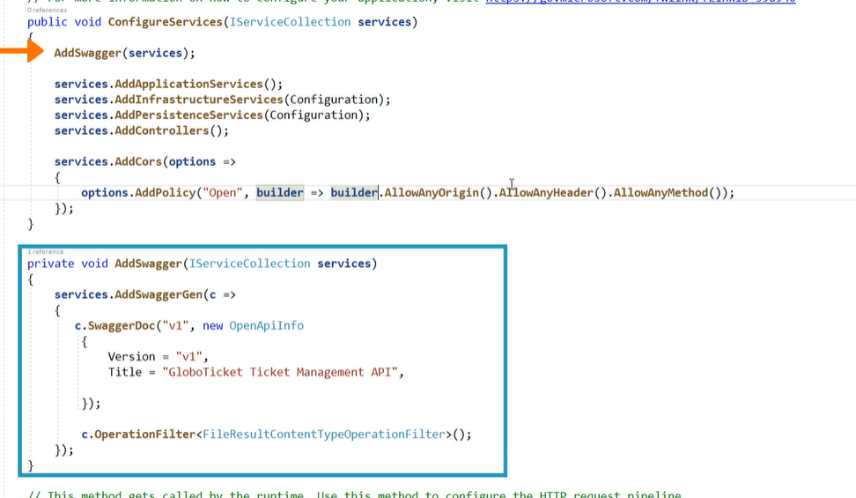

Register swagger and set up

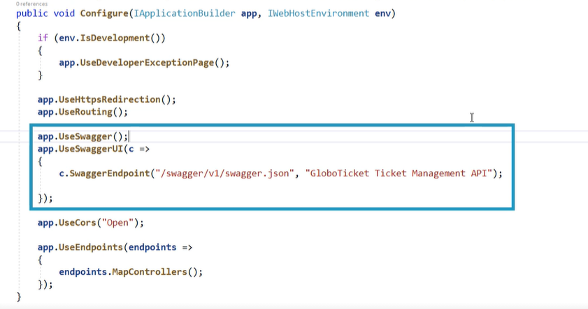

Add middleware for swagger and swaggerUI

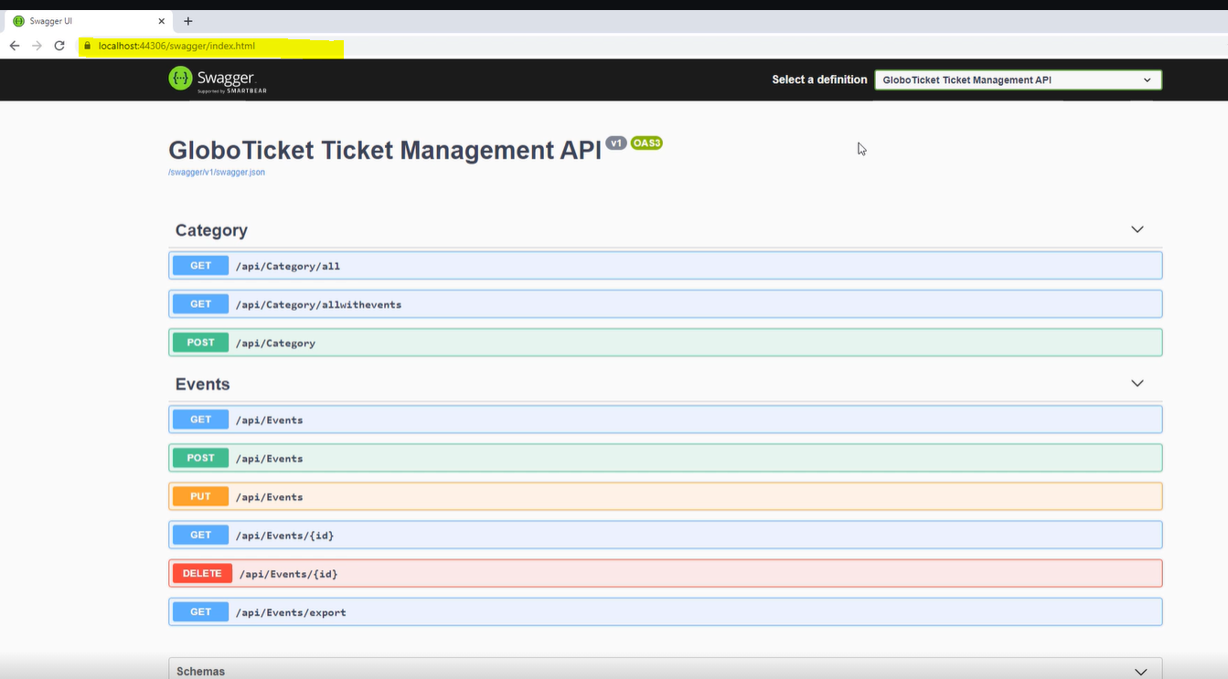

Start application and go to picture under to see a swagger documentation.

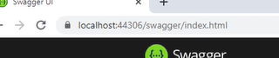

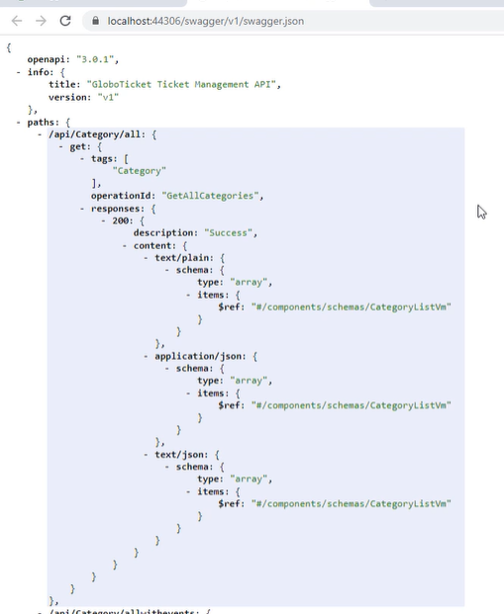

Swagger can get your json from API add /v1/swagger.json.

And now our API is completed.

## Tests